Data Mining and Machine Learning for Business

DSCI 5240.003

Dr. Russell Torres

**Project - Final Report**

**Predicting Indicators Importance for Human Development**

Group 4:

Zhang, Canhong

Dhakal, Shristi

Choi, Bomi

Abi Yaghi, Angele

Fall 2019

**Table of Contents**

**1.** **Executive Summary** 3

**2.** **Project motivation/ Background** 3

**3.** **Data Description** 4

**3.1.** **Data Sampling** 4

**3.2.** **Exploring and Understanding the Variables** 4

● **Correlations Between Each Variable and the Target Variable** 7

● **Variable Worth** 8

**4.** **Data Preprocessing** 9

**4.1.** **Data Cleanup** 9

**4.1.1. Missing Values** 9

**4.1.2 Noisy Data** 10

**4.1.3 Normalizing Variables** 13

**4.2** **Data Integration** 15

**4.2.1** **Dimensionality Reduction** 16

● **Standardization** 16

● **Variable Selection Approach** 17

**4.3** **Data Exploration** 19

● **Behavior of the Variables (StatExplore node)** 19

● **Relationship of the Variables** 20

**5.** **Cluster Analysis** 21

**6.** **Data Modeling & Data Interpretation** 24

**6.1 Linear Regression Models** 24

**6.2 Regression Tree Models** 31

**7. Model Comparison and Conclusions** 39

**8.** **Managerial Implications** 41

**9.** **Limitations** 43

**10.** **References and Links:** 48

# **Executive Summary**

This project is an attempt to identify the importance of different indicators that can be related to the measurement of the Human Development Index. HDI currently has three main indicators: Longevity - measured by life expectancy at birth, Education or Knowledge - measured by weighted average of adult literacy and mean years of schooling, and Standard of Living - measured by real per capita income of a country at purchasing power parity (PPP) prices (Ayesha, n.d.). In this project, we used the indicators that are not directly used in the calculation of the HDI at present, explored the dataset, modified the data using different mathematical techniques, and ran different linear regression models, regression tree models, and cluster models on the data set. To run and test the models, 26 indicators listed under the World Development Indicators, some of which are not currently used in HDI calculation, were used.

# **Project motivation/ Background**

One of the limitations of the Human Development Index is that it is not a full measure of human development. It only includes the most essential dimensions of human development but does not include a number of other dimensions that could be important in evaluating a human development. For this reason, HDI needs to be supplemented with other important indicators to get a more overall picture of human development (Jahan, n.d.). This was a motivation for the project i.e. to find out which other variables are more important in predicting the Human Development Index of a country. This attempt could help non-profit organizations to fund and support the most important causes by identifying the most important development indicators, and furthermore, aid undeveloped countries to improve their human development index.

# **Data Description**

# **3.1. Data Sampling**

Second-hand data was used for this project. To ensure accuracy, completeness, timeliness, believability, and interpretability, the dataset was obtained from the World Bank online database, which is globally known to be a reliable source of information and is updated at least on a yearly basis.

The variables were chosen manually before downloading the data. There were 48 variables in the original dataset. Given that the variables that have more than 25% missing values affect the believability of analysis result, these variables were manually deleted before the analysis. Besides, observations that did not have HDI value in the original data were deleted because these observations affected the accuracy of the analysis. Observations that grouped some countries together (such as the Caribbean region and the European Union) were also deleted as they could have resulted in redundancy. Therefore, the new database includes a total of 27 variables, which includes information from 168 countries for a period of 5 years (2013-2017), for a total of 840 observations. The introduction of all variables is shown in Appendix 1. The target variable is the Human Development Index (HDI), which explains the level of human development that would be achieved if a set of indicators resulted to be significant for the model.

## **3.2. Exploring and Understanding the Variables**

* **Variables’ Levels and Roles:**

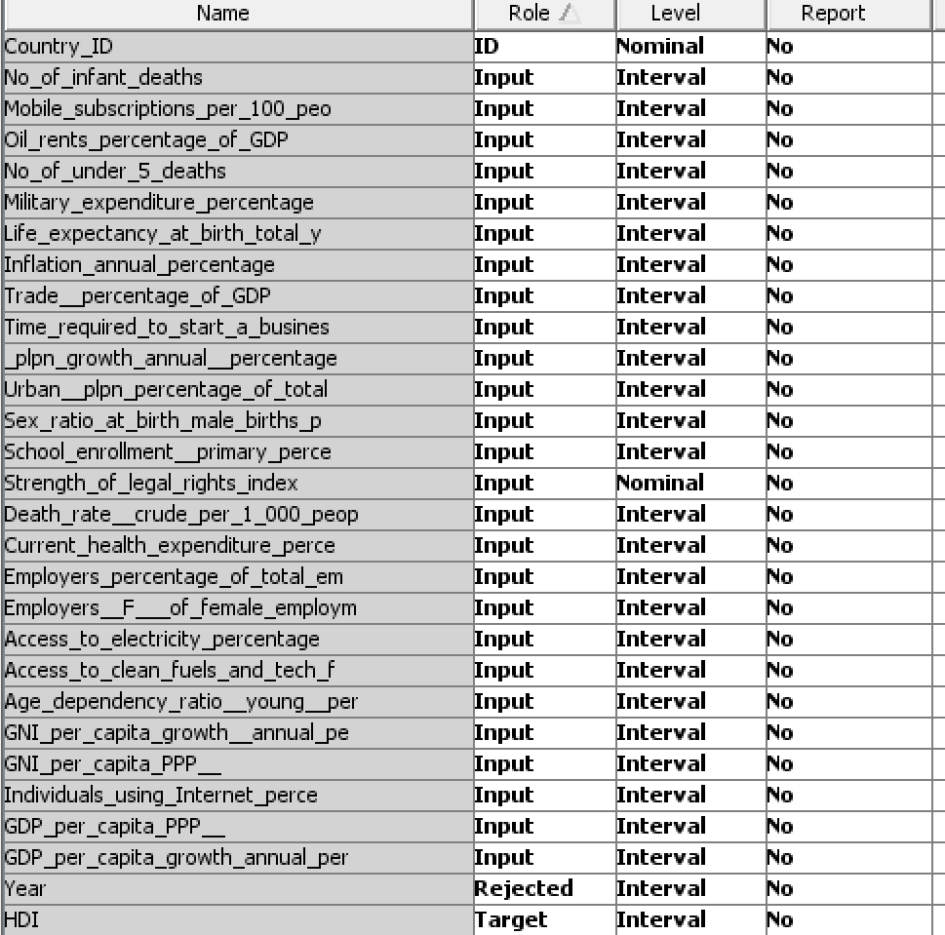

* **General statistic measures of variables:**

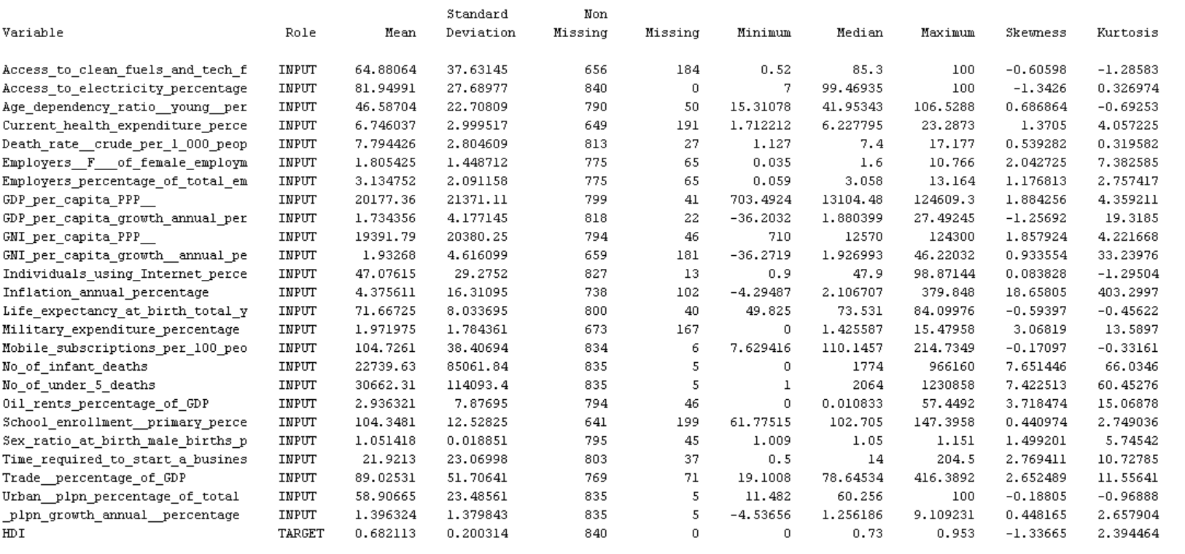

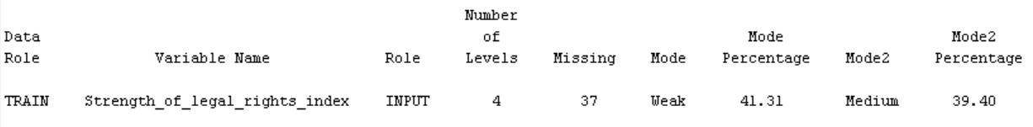

According to the results in the table above, the variable ‘’Inflation annual percentage’’ is highly skewed (Skewness = 18.66), followed by the variables ‘’Number of infant deaths’’ and ‘’Number_of_under_5_deaths’’. The variable ‘’Oil rents percentage of GDP’’ is slightly skewed and the remaining variables have a normal skewness. The criteria was that a skewness between -3 and +3 is a normal skewness. The 4 variables that do not have this requirement would have to be transformed to make them fit into a normal distribution.

Additionally, 7.58% of the data (1,655 values of 21,840 total values) is missing for the independent variables. Standard deviations are also very large in these variables: ‘’GDP per capita PPP’’, ‘’GNI per capita PPP’’, ‘’Number of under 5 deaths’’ and ‘’Number of infant deaths’’. This is because the different values for each of those variables fall in a large range. The nominal variable (Strength_of_legal_rights_index) has 37 missing values. It has three levels: Weak, Medium, and Strong, with a respective percentage of 41.31%, 39.4% and 19.29%.

* **Histograms and Distribution of the variables:**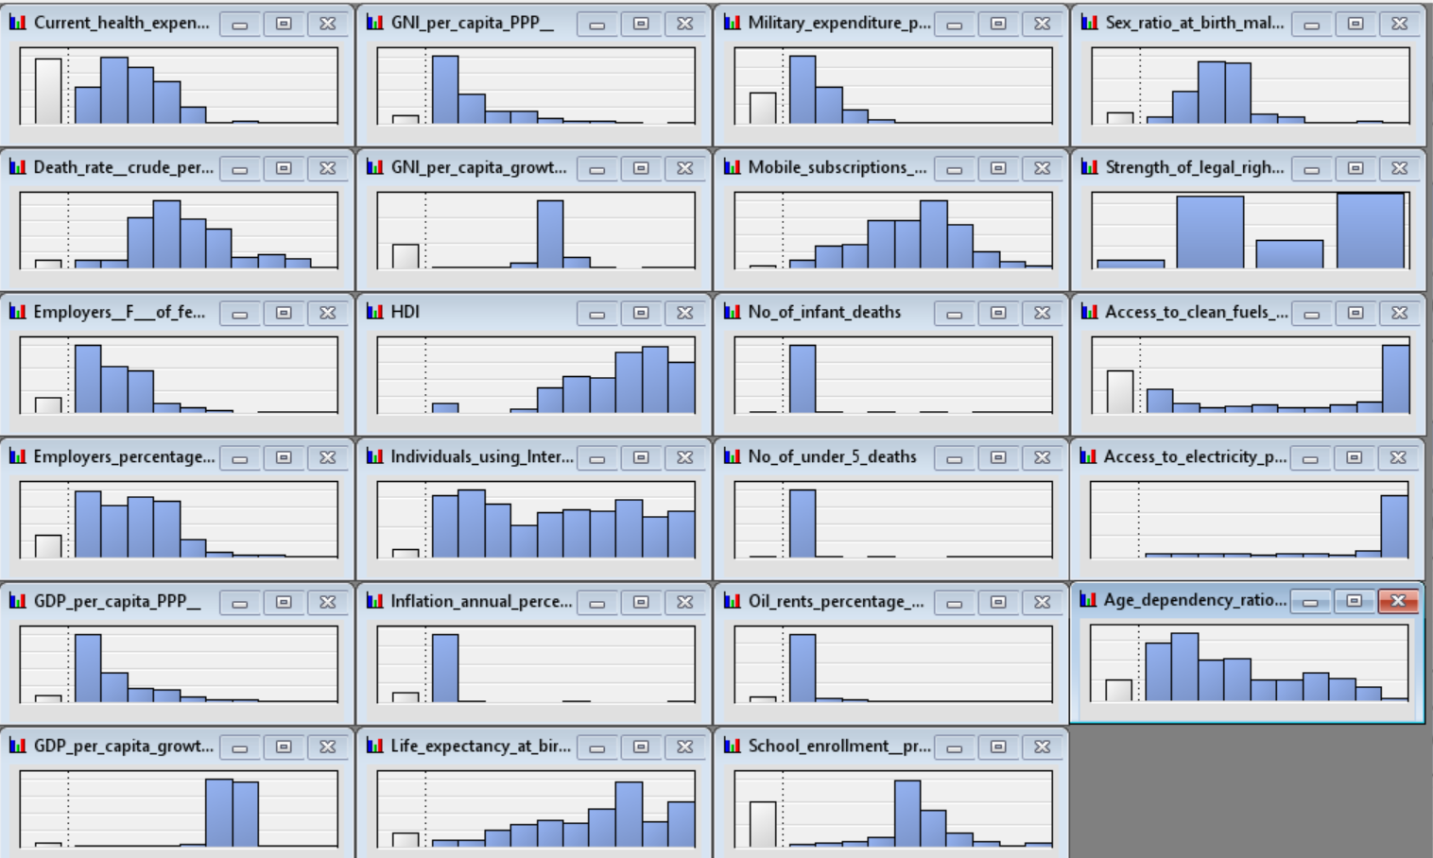

The histograms show that some variables are skewed and do not follow a normal distribution, which is also previously explained in the general statistic measures. For these variables, a transformation needs to be made to force them to be normal. The white columns in the left of each graph shown above represent the missing data. The missing data will be handled and the methods used to do so will be explained in the next section.

### **Correlations Between Each Variable and the Target Variable**

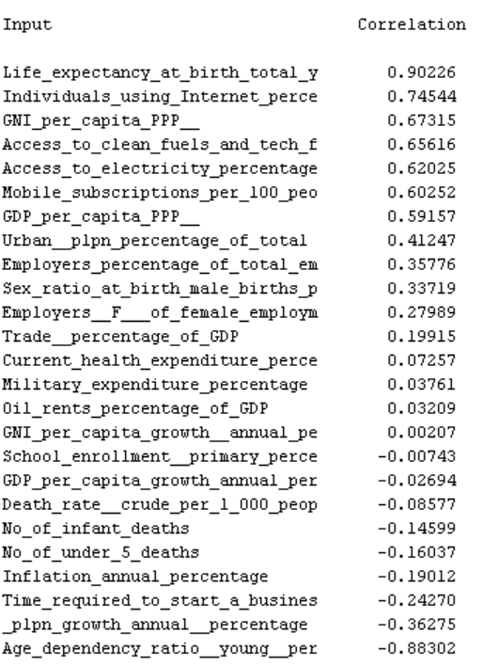

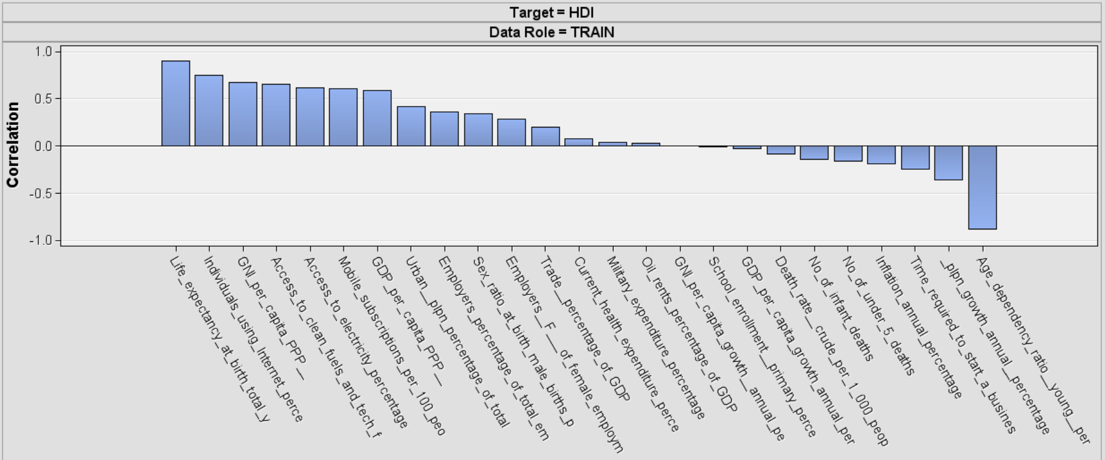

The most positively correlated variable is ‘’life expectancy at birth’’ and the most negatively correlated variable is ‘’young age dependency ratio’’. These two variables are also expected to be the ones that have the greatest influence on the change of HDI.

### **Variable Worth**

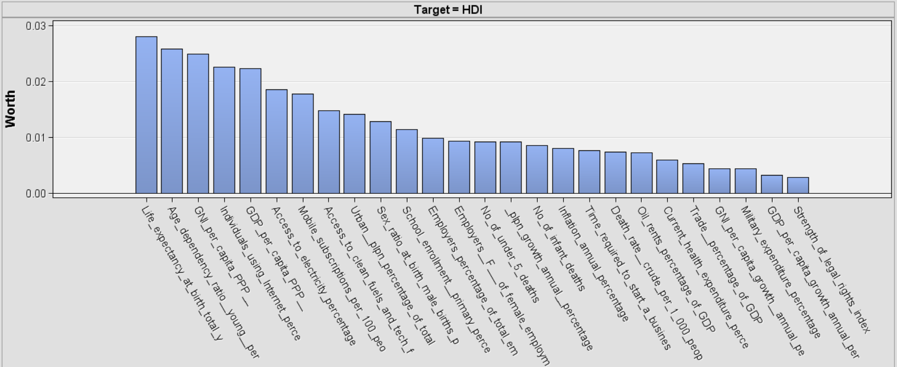

The graph shows how important each particular variable might be in this model.

To sum up the data sampling process, the general exploration of the data gave us some interesting results, but further analysis is needed after the cleanup process to know if the correlations and ranking of the variables shown above are actually true.

# **Data Preprocessing**

Preprocessing is done to impute the missing values and get rid of the noisy data. This is to ensure that missing values and noisy data do not alter our results from being accurate and complete.

## **4.1. Data Cleanup**

### **4.1.1. Missing Values**

All variables, except “HDI” and “Access to electricity percentage” in the dataset, include missing values. Each of these variables has less than 24% of missing values, as seen in the table below. Considering that the dataset has missing values for almost all the variables that are intended to be used in the model, an Impute node is used to deal with these. The method used to fill in missing values is “Tree Surrogate” with a missing values cutoff of 100%.

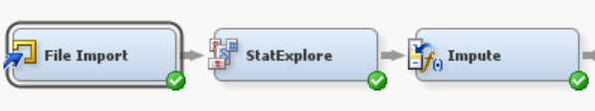

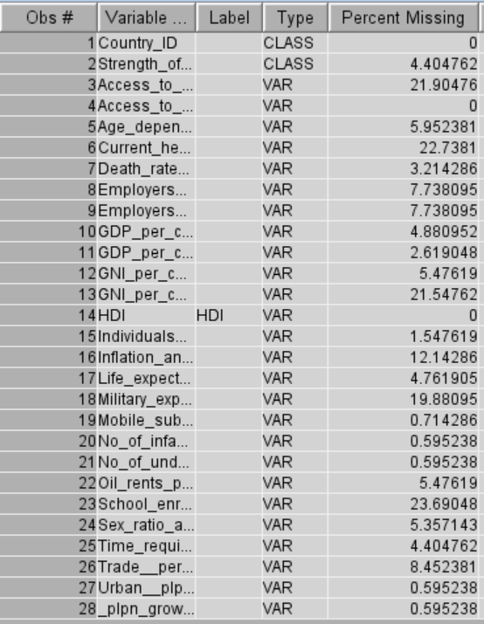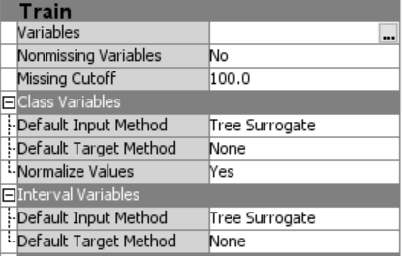

### **4.1.2 Noisy Data**

Outliers need to be reviewed and removed so that they do not skew the distribution and final results of the model. For this, box plots and histograms were used to identify if the dataset has outliers.

* **Box Plots**

The box plots below show that at least 12 variables have outliers.

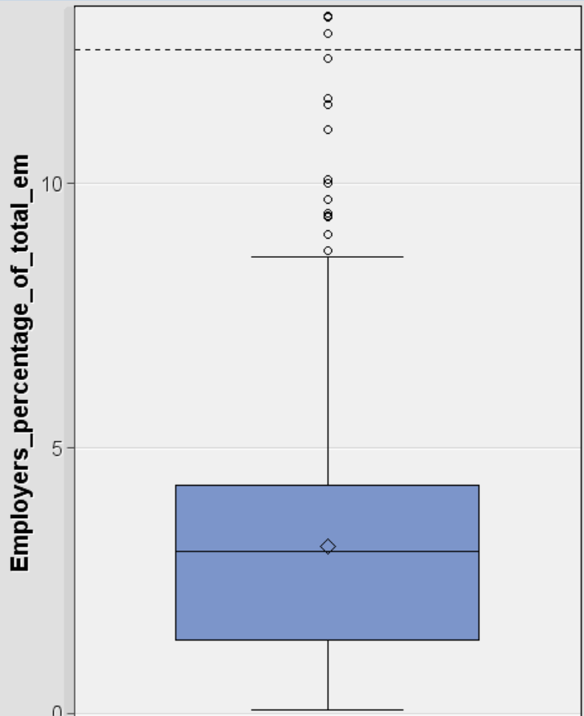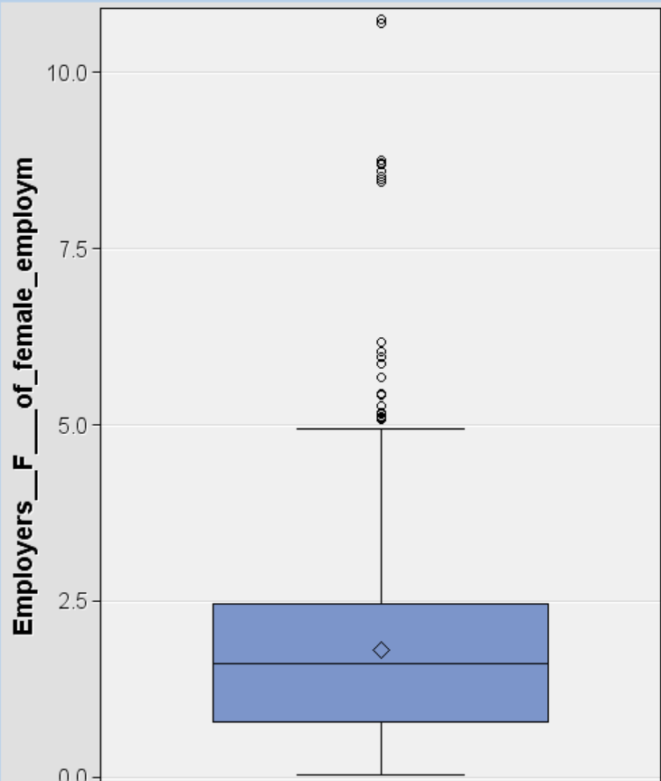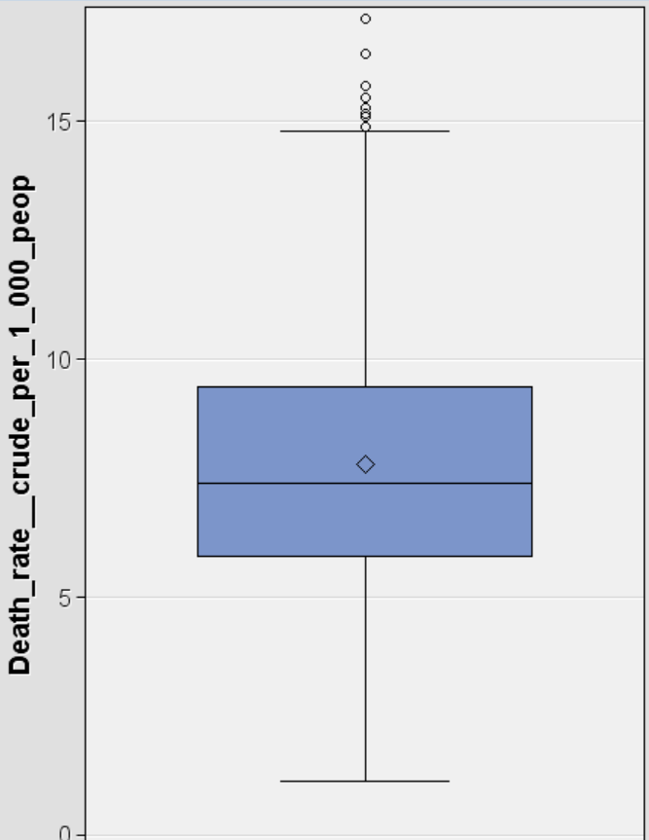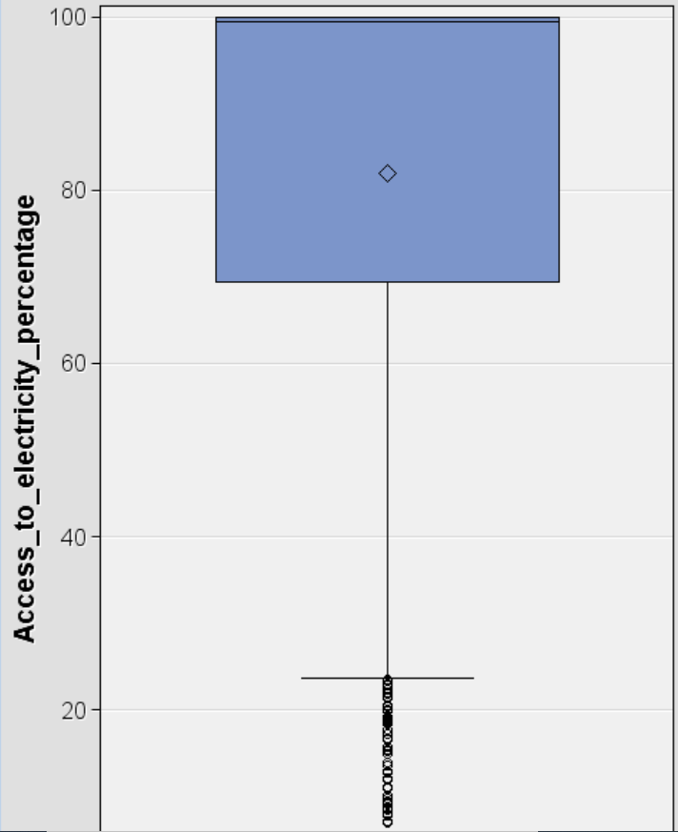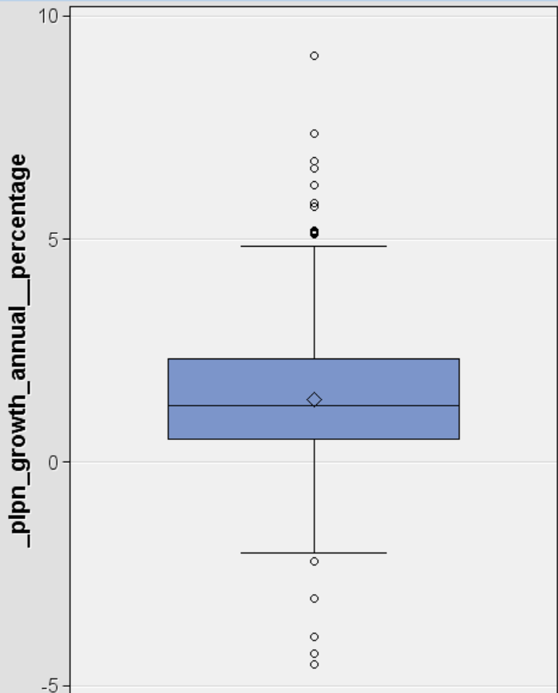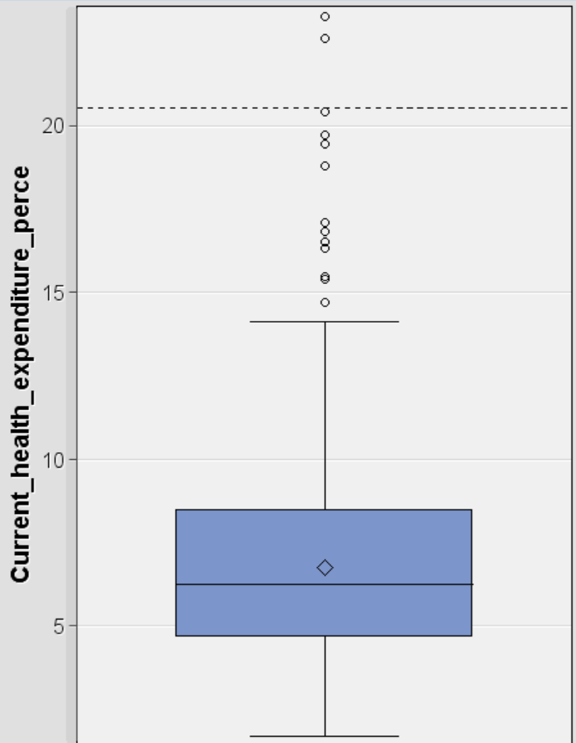

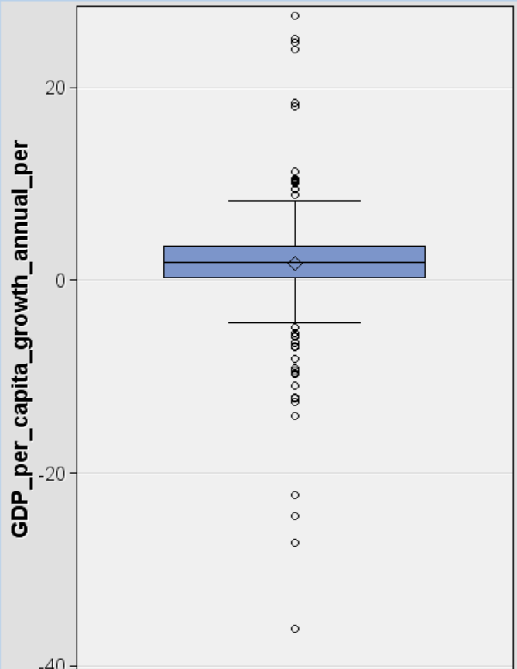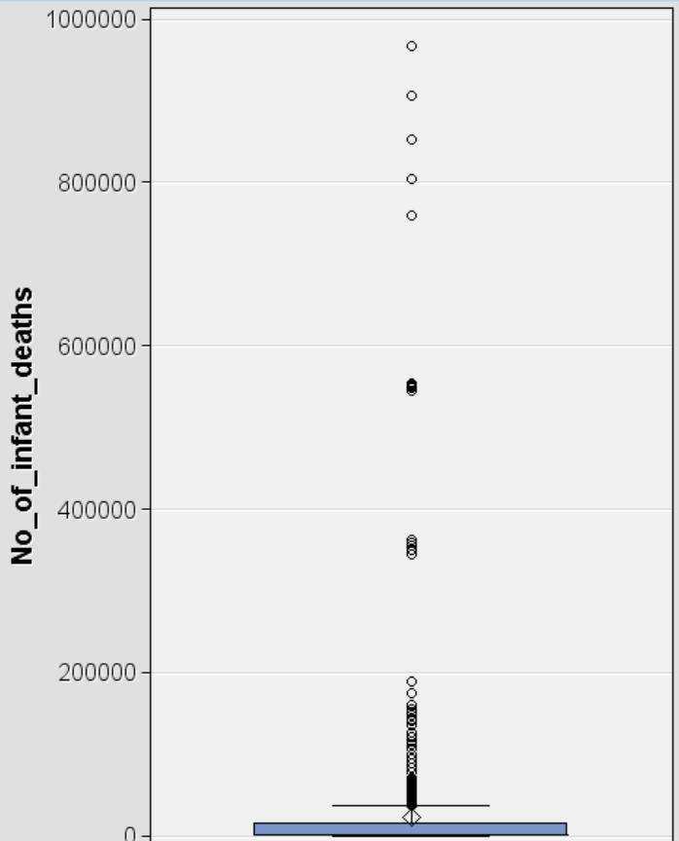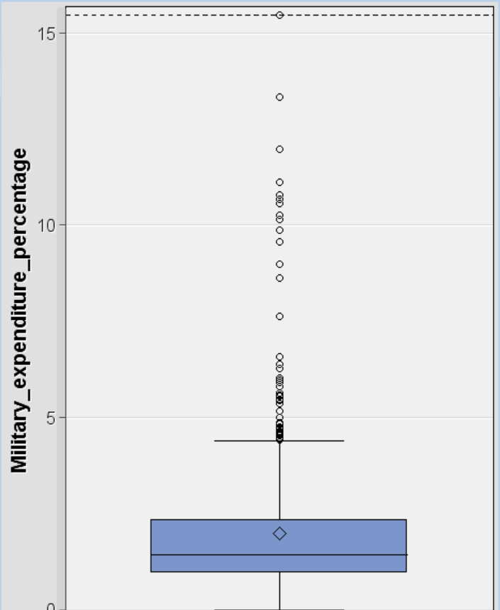

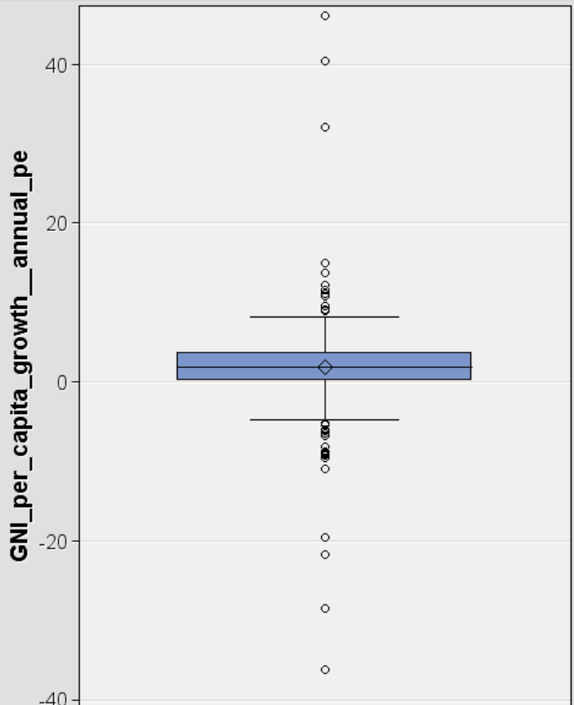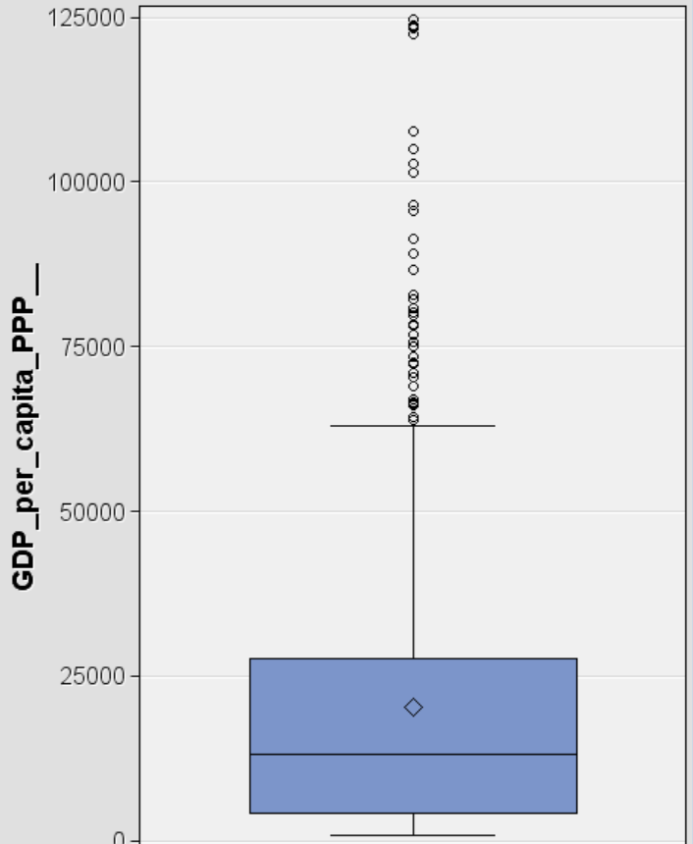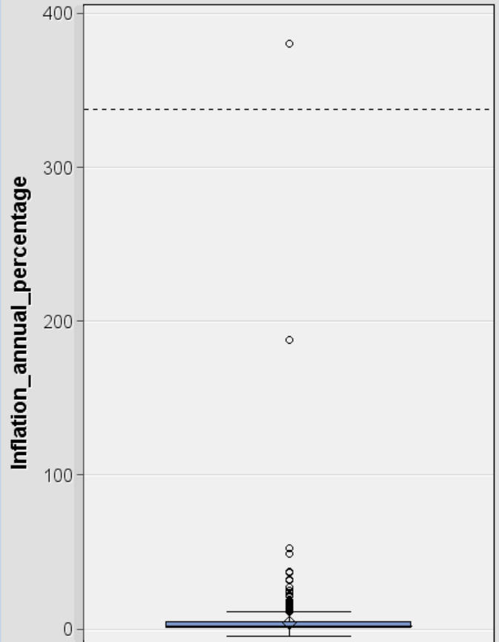

* **Histograms**

The outliers identified in the box plots above are also visible in the histograms. Below are the histograms of some of these variables.

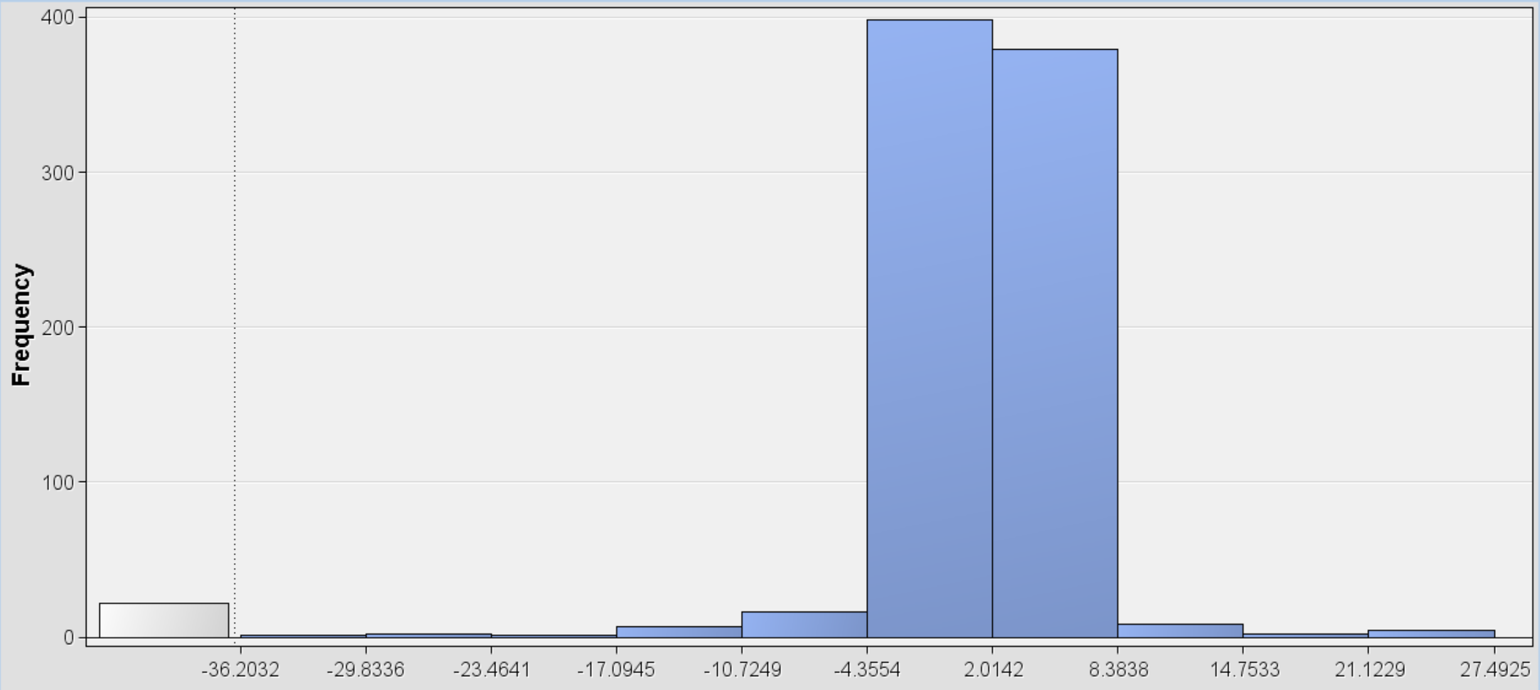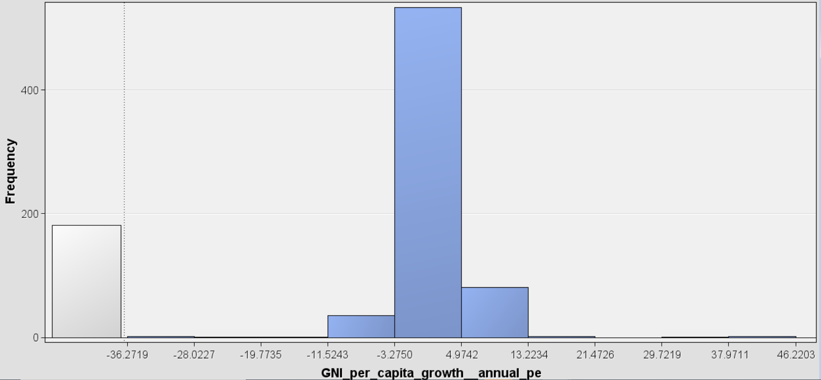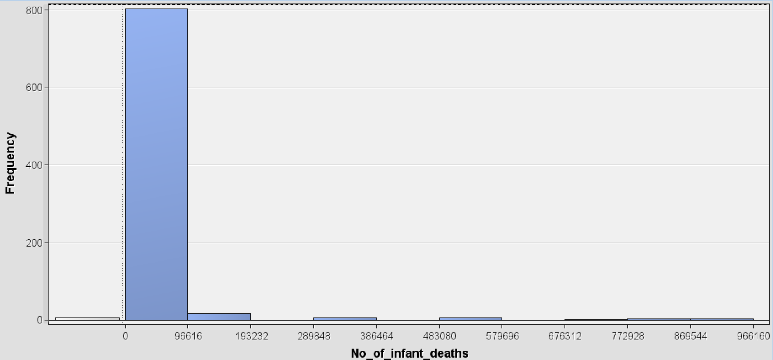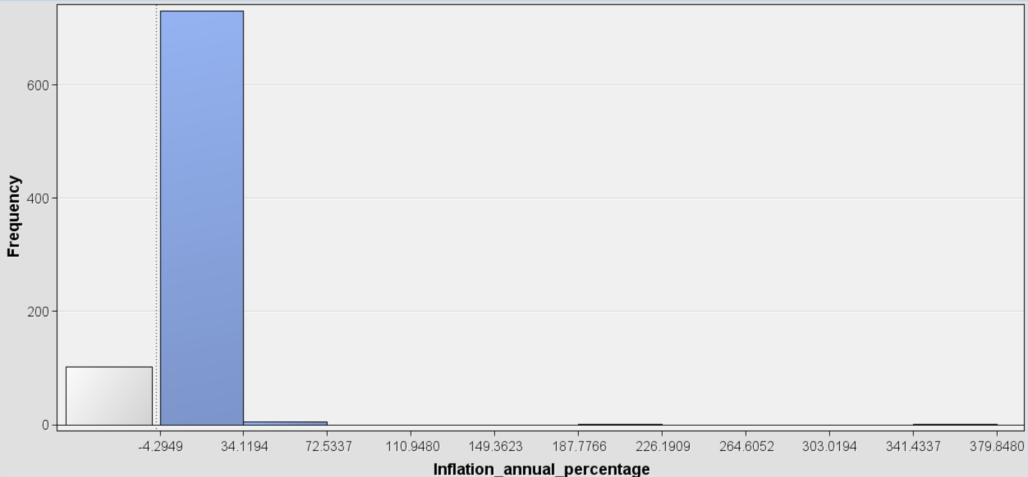

A Filter node was added to eliminate the outliers that were creating noise in the data.

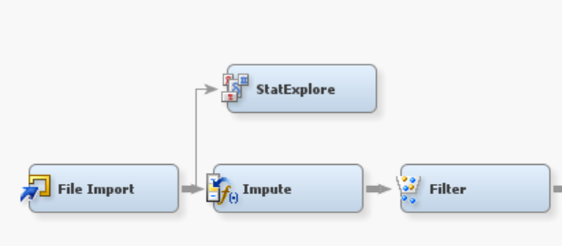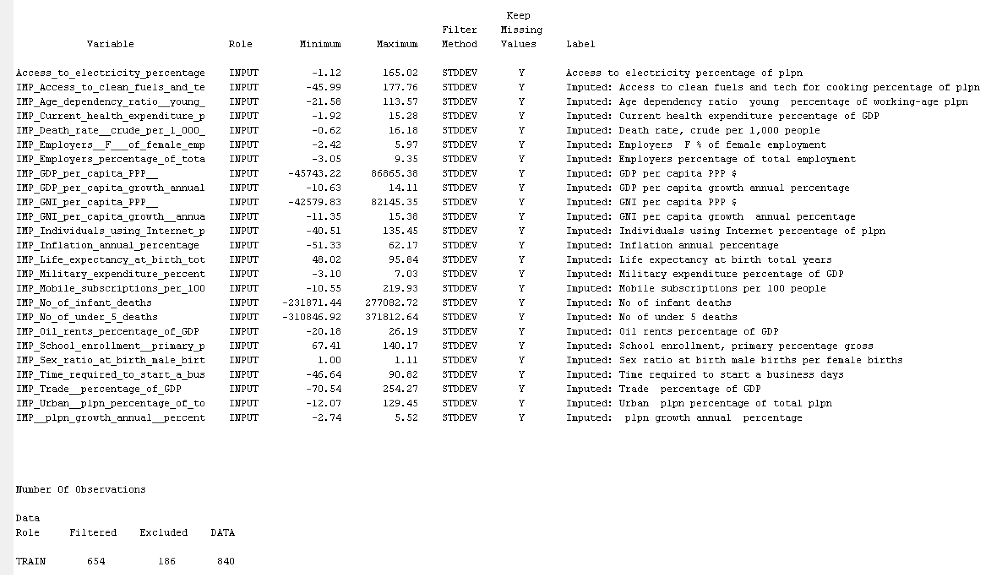

### **4.1.3 Normalizing Variables**

Data transformation improves the model response by countering non-normality. According to the histograms and high skewness analyzed before, the following 4 variables were transformed using the ‘’Transform Variables’’ node and the “Log10” transformation method:

* Inflation annual percentage
* Number of infant deaths
* Number of under 5 deaths
* Oil rents percentage

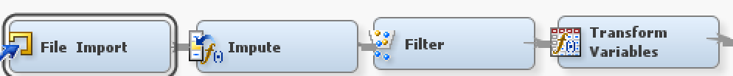

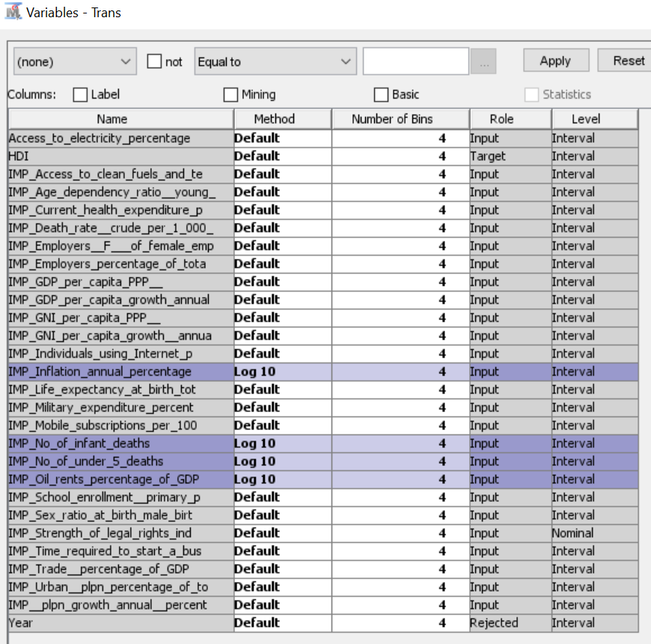

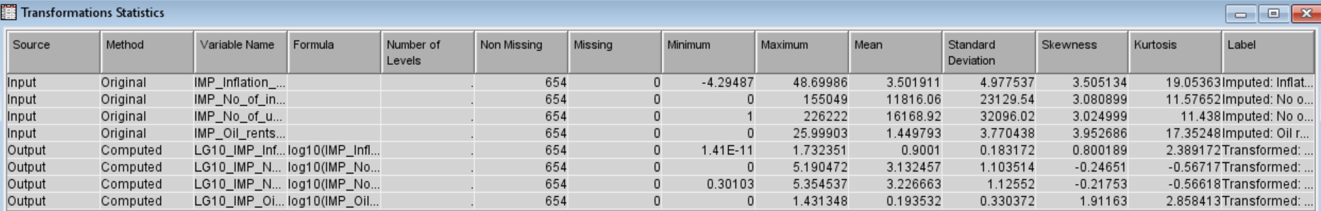

As seen in the Transformation Statistics table above, the skewness of the variables selected was reduced to the acceptable range and are expected to have a normal distribution after completing this transformation.

## **4.2 Data Integration**

Presence of duplicate data and conflicts of values were reviewed so that they would not overweight or underweight the importance of some variables.

The variable “Military expenditure’’ now seems to follow a normal distribution. The level of high skewness for “Inflation annual percentage’’, “Number of infant deaths’’, “Number of under 5 deaths’’, and “Oil rents percentage of GDP’’ is reduced and now they are only slightly highly skewed. The table below shows the results we got:

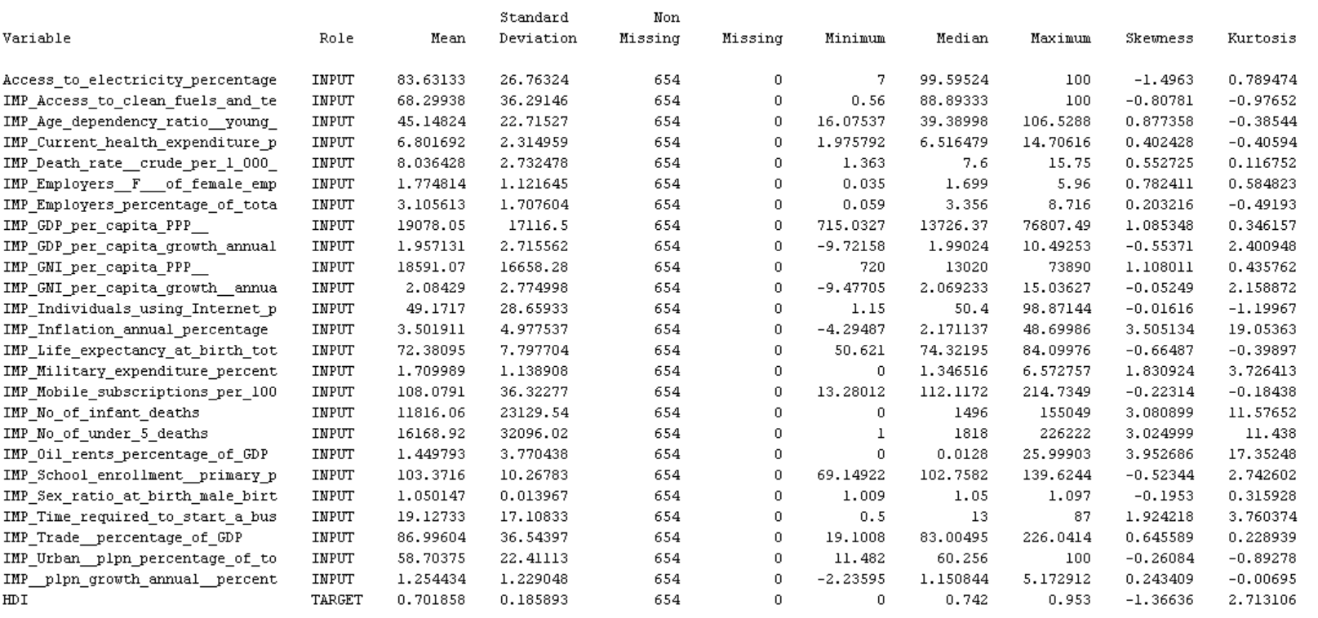

### **4.2.1 Dimensionality Reduction**

Some variables needed to be standardized to improve the model’s response by stabilizing the variance. For this reason, a second “Transform Variable’’ node was added to the diagram and the nominal variable was excluded from this process.



#### **Standardization**

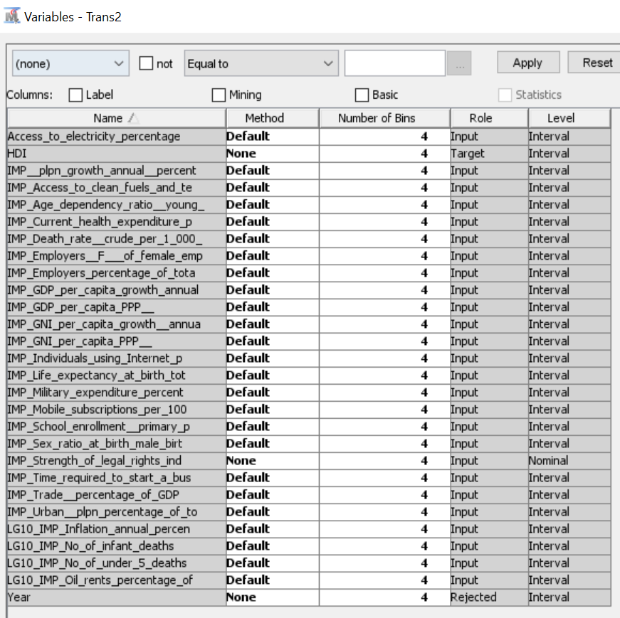

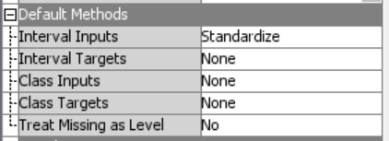

#### **Variable Selection Approach**

Any column that could be originated from other columns was identified to reduce redundancy.



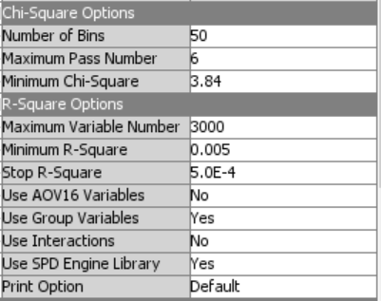

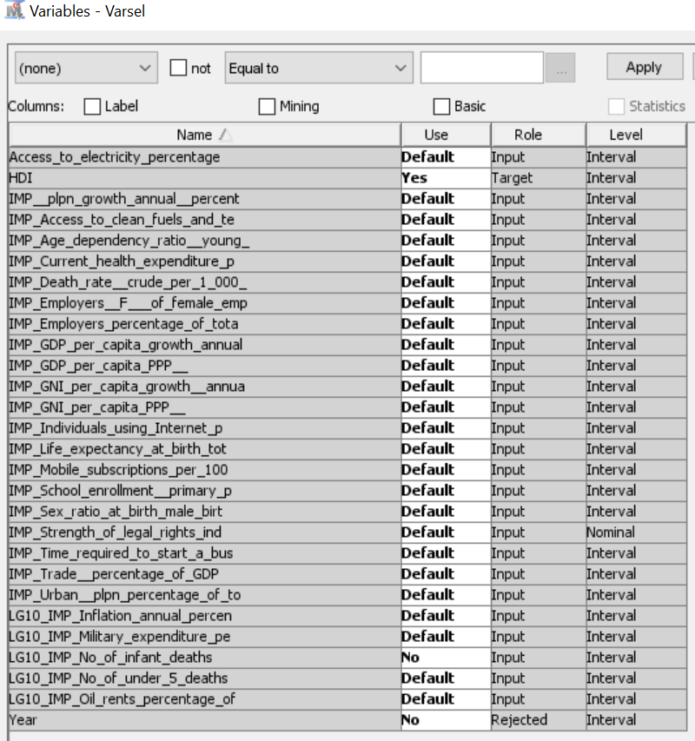

There were two overlapping variables: ‘’Number of infant deaths’’ and ‘’Number of under 5 deaths’’, hence, “Number of infant deaths” variable was excluded from the model using the ‘’Variable Selection’’ node.

A variable selection algorithm was run after excluding that variable. The minimum bounds to be approved as a valid variable for the model were specified to be the default criteria given by the node (Minimum R square of 0.005 and a minimum Chi square of 3.84). The results show that 10 variables were rejected because they did not have the minimum requirements of R square and Chi square required as shown in the table below:

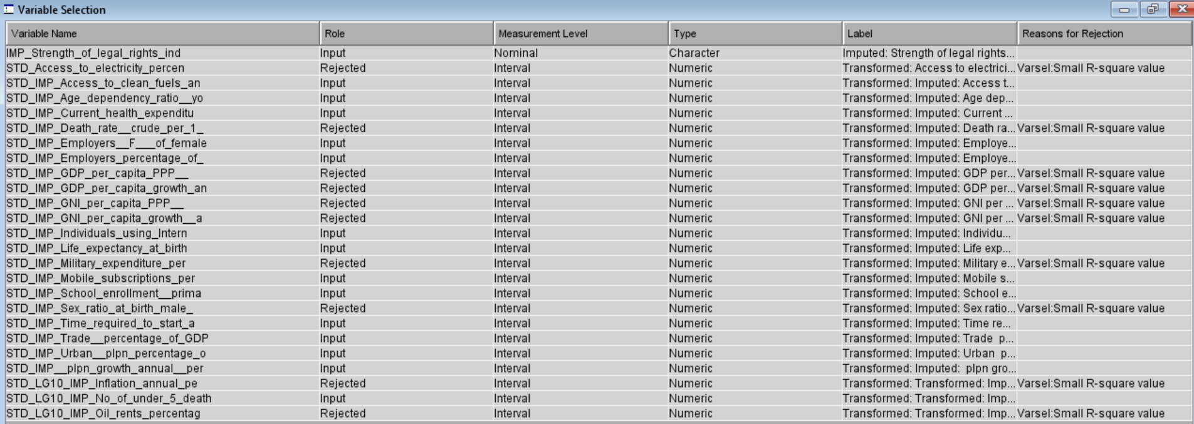

The first 15 variables in the following graph were considered significant (in order of acceptance), according to the criteria.

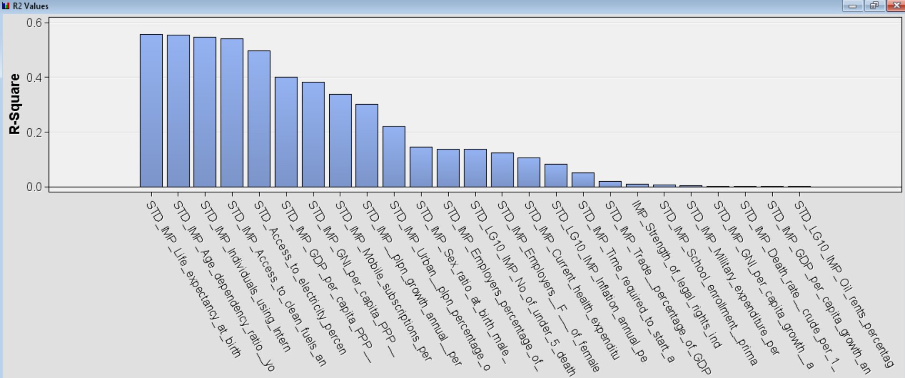

The R square in the graph below shows the effect of each variable in the model. The variable ‘’Life expectancy at birth” is the most important one by far with a 55.57% of effect in the model.

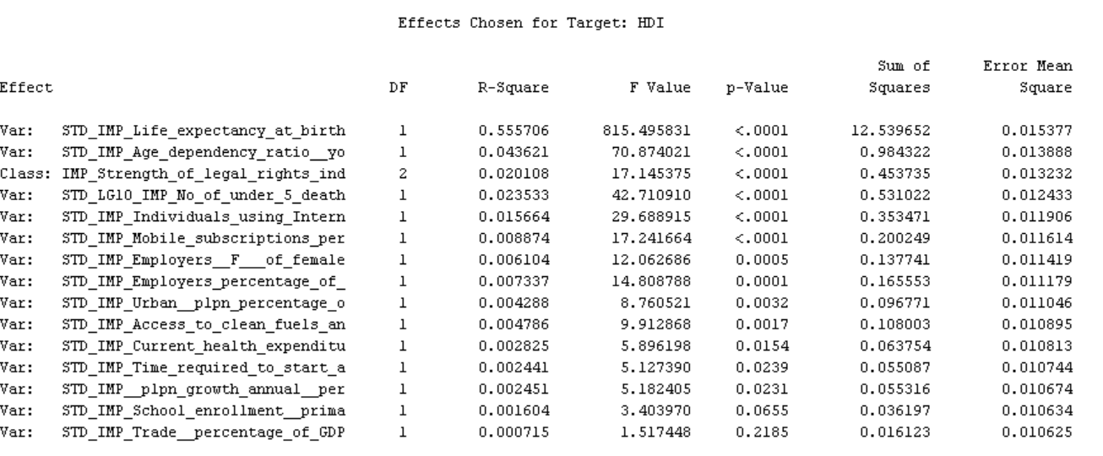

These 15 variables are going to be used as input for the third and the fourth linear regression and regression tree models.

## **4.3 Data Exploration**



After the data integration process was completed, a ‘’StatExplore’’ node was added with the remaining 15 variables as input.

### **Behavior of the Variables (StatExplore node)**

The table below shows the general statistics of the remaining variables after the transformation process. The skewness and the standard deviation are normal and there are no missing values.

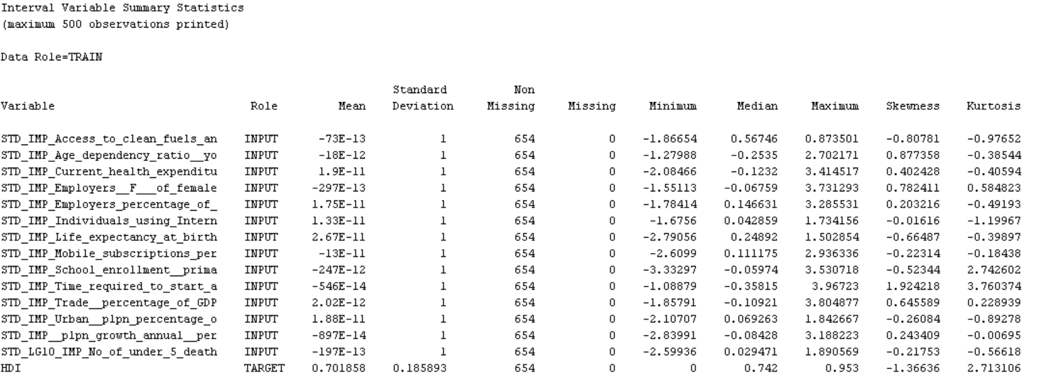

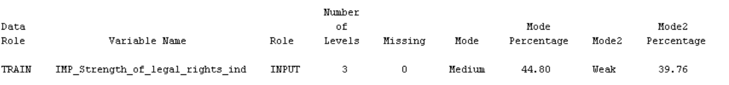

### **Relationship of the Variables**

The most positively correlated variable with a correlation above 0.5 is ‘’Life expectancy at birth’’ followed by ‘’Individuals using internet’’, ‘’Access to clean fuels’’ and ‘’Mobile subscriptions’’. And, the most negatively correlated variable with a correlation below -0.5 is ‘’Young age dependency’’ followed by ‘’Annual correlation growth’’.

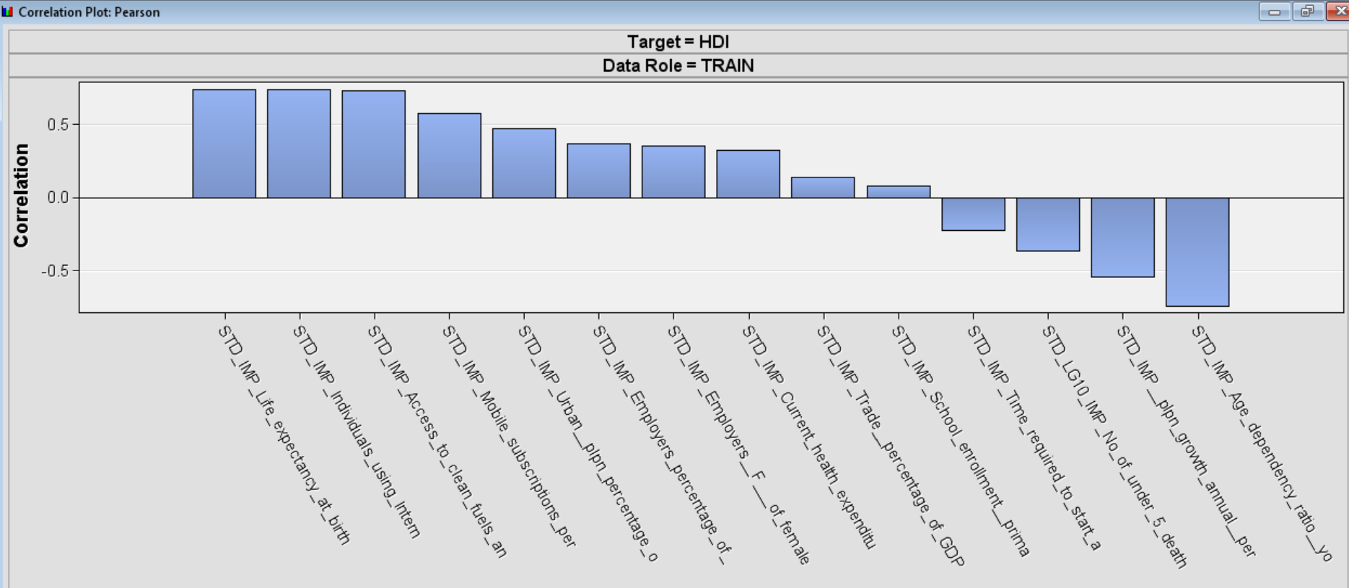

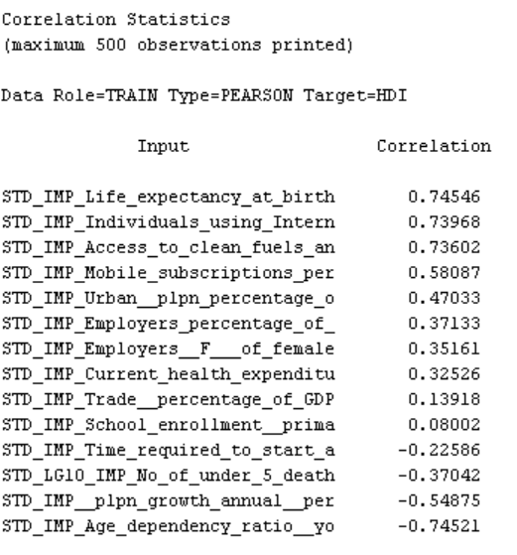

# **Cluster Analysis**



A cluster node was added to see interesting patterns, if any, in the dataset. After specifying the cluster training settings as shown below, we separately added cluster nodes after the File Import node and the Variable Selection node. Variables with large variance value tend to have more effect on the resulting clusters than variables with small variance values. So, clusters use standardization to solve this issue. Cluster node uses the automatic specification method and specifies the maximum number of clusters.

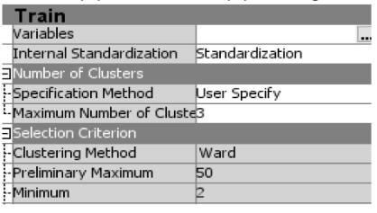

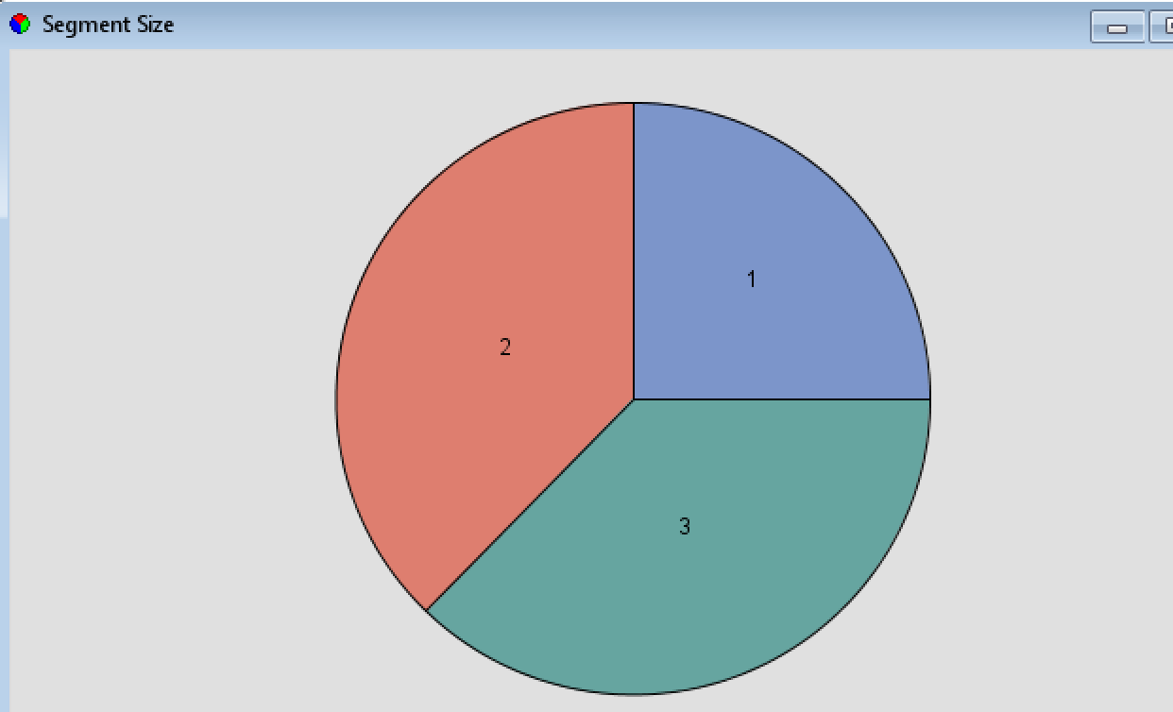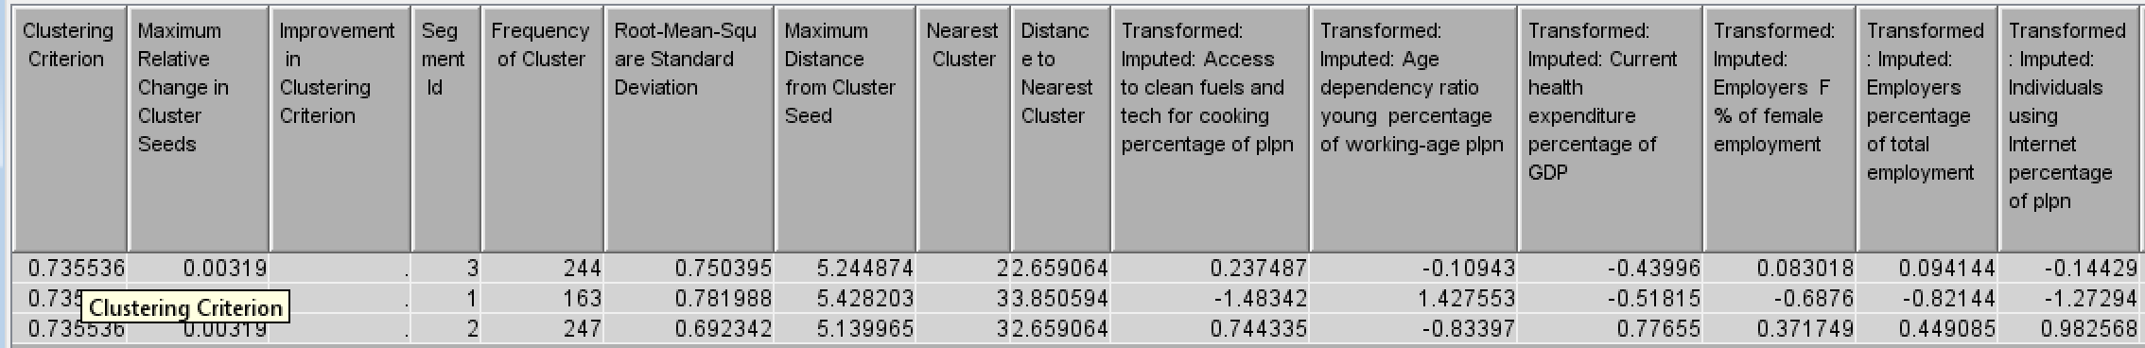

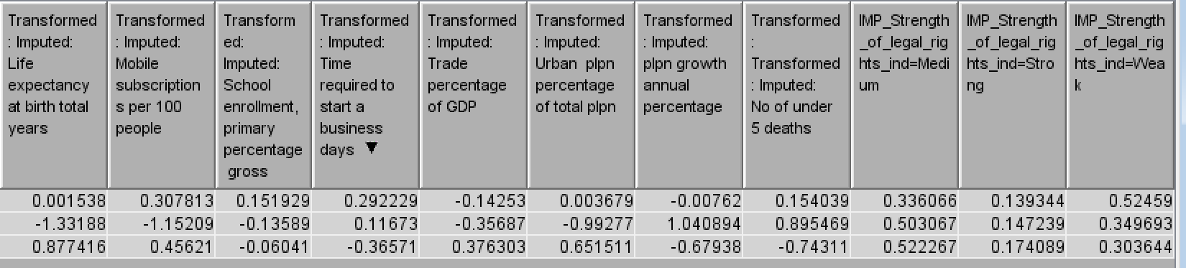

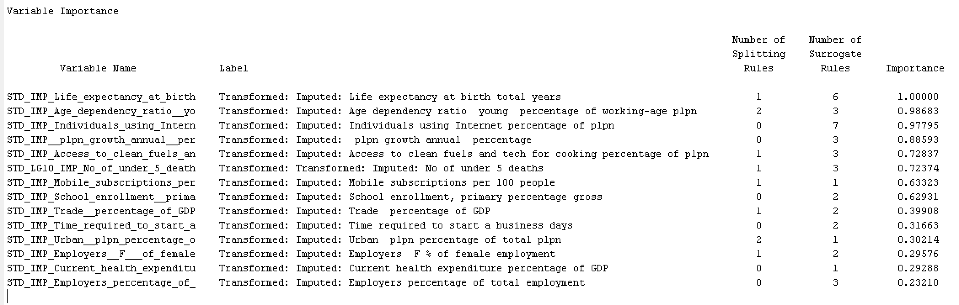

After preprocessing for missing data, outliers, skewness data, and redundant data, the cluster node categorized 654 observations into three segments. The skewness issue does not exist now and the variable that causes redundancy is not included. 163 observations are classified into Segment 1, 247 observations are classified into Segment 2. 244 observations are classified into Segment 3. In Cluster (2), 14 interval variables are used for generating segments. The results show that the five most important variables are: “Life expectancy at birth, total (years)”, “Age dependency ratio, young (% of working-age population)”, “Individuals using the Internet (% of population)”, “Population growth (annual %)”, and “Access to clean fuels and technologies for cooking (% of population)”.

Distance between Segment 3 and Segment 2 is closer than their distance to Segment 1. Segment 2 has the characteristics of developed countries that show a higher mean value on access to clean fuels and technology for cooking, health expenditure percentage of GDP, the percentage of women's employment, the percentage of individuals using the internet, life expectancy at birth, mobile subscriptions per 100 people, the percentage of urban population, and have shorter time required to start a business, lower dependency on young working-age population, a lower number of under-five deaths, and lower population growth rate. Segment 3 can be said to be developing countries that have a middle level of mean values for most variables. Segment 1 is close to the characteristics of underdeveloped countries that have a low mean value on access to clean fuels and technology for cooking, health expenditure percentage of GDP, the percentage of women's employment, the percentage of individuals using the internet, life expectancy at birth, mobile subscriptions per 100 people, the percentage of urban population, and have a long time required to start a business, high dependency on young working-age population, a high number of under-five deaths.

# **Data Modeling & Data Interpretation**

* **Data Partition (60/20/20 and 30/40/30):**

Two data partition nodes were run; the first node with 60% training data, 20% validation data, and 20% testing data; the second node with 30% training data, 40% validation data, and 30% testing data. In both data partition nodes, a “Simple Random Sampling” method was chosen. And, all the models we ran depended upon on these two data partitions.

## **6.1 Linear Regression Models**

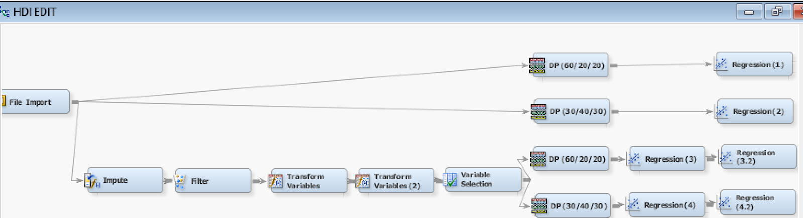

The target HDI is an interval variable and linear regression model can be used to predict the relationship between independent variables and the continuous target variable. So, we used linear regression models for the analysis.

* **Model Settings:**

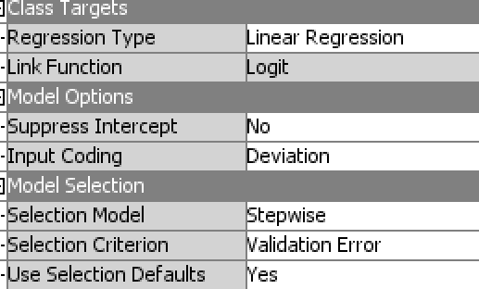

Four linear regression models were separately run through Stepwise tool and Validation Error.

Before impute, transform variables, and variable selection nodes:

1. **Linear Regression 1:** Data Partition 60/20/20
2. **Linear Regression 2:** Data Partition 30/40/30

After impute, transform variables, and variable selection nodes:

1. **Linear Regression 3**: Data Partition 60/20/20
2. **Linear Regression 4**: Data Partition 30/40/30

The following results were obtained:

* **Model: Linear Regression (1)**

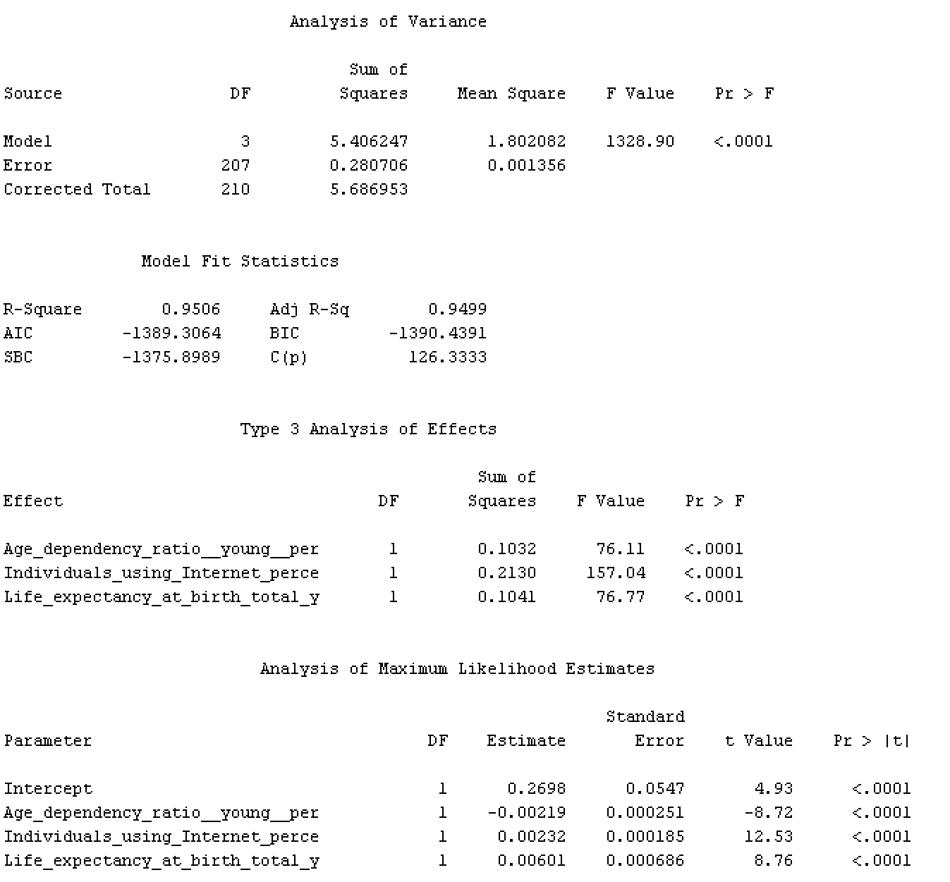

Linear regression model by default drops the observations that have missing data. So, this model is trained based on 210 observations. Linear regression (1) is significant because its Pr>F is smaller than 0.05 significance level. Only three independent variables are significant in this model and they explain 95.06% of the variance because their Pr>F is smaller than 0.05 significance level and their R square is 0.9506. The three variables are “Age dependency ratio, young (% of working-age population)”, “Life expectancy at birth, total (years)”, “Individuals using the Internet (% of population)”. The fit statistics results show the average squared error from the validation data and test data is not larger than the error from training data.

**Linear Equation:**

$$\hat{HDI}= 0.2698-0.00219 Age dependency ratio+0.00601 Life expectancy at birth +0.00232 Individuals using Internet$$

* **Model: Linear Regression (2)**

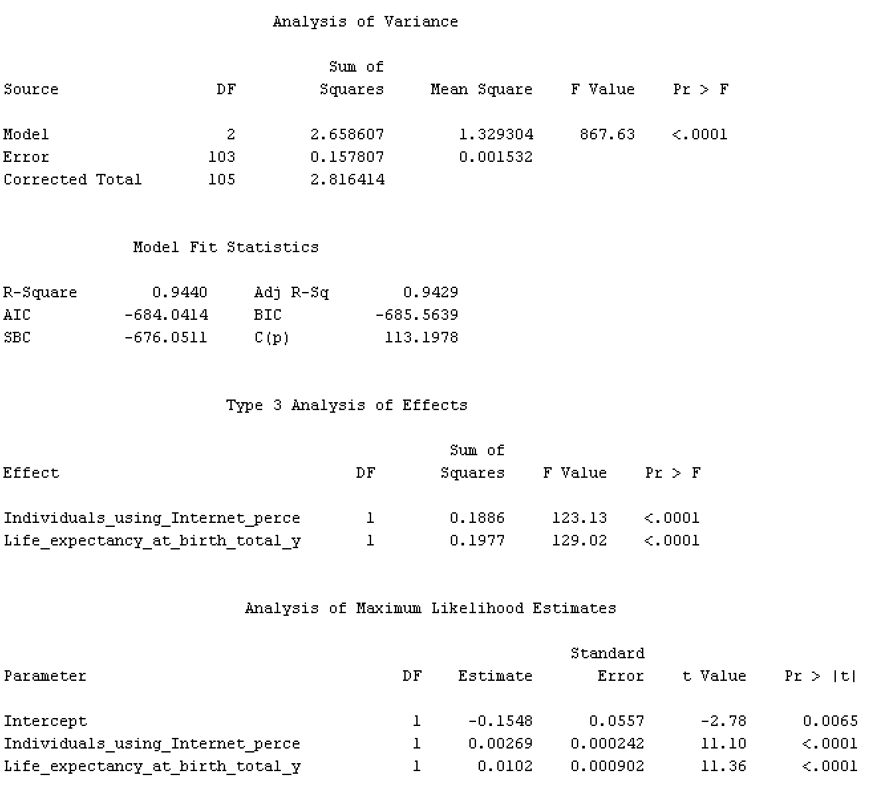

This linear regression model uses different percentages in data partitioning node. So, this model is trained based on 105 observations. Linear regression (2) is significant because its Pr>F is smaller than 0.05 significance level. Only two independent variables are significant in this model and they explain 94.40% of the variance because their Pr>F is smaller than 0.05 significance level and R square is 0.9440. Two variables are “Life expectancy at birth, total (years)”, “Individuals using the Internet (% of population)”. The fit statistics data shows the average squared error from the validation data and test data is less than the error from training data.

**Linear Model:**

$$\hat{HDI}= -0.1548+0.0102 Life expectancy at birth +0.00269 Individuals using Internet$$

* **Model: Linear Regression (3)**

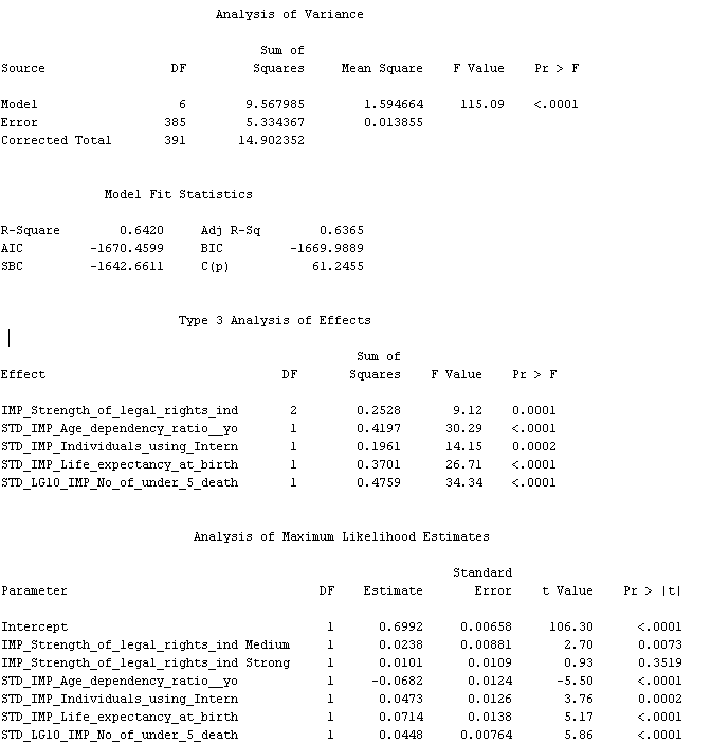

This model is trained based on 391 observations. The model is significant but ‘’Strength of legal rights (Strong)’’ is not significant according to the t test, as its p value is greater than 0.05. The model was run again rejecting this variable and these were the results we obtained:

* **Model: Linear Regression (3.2)**

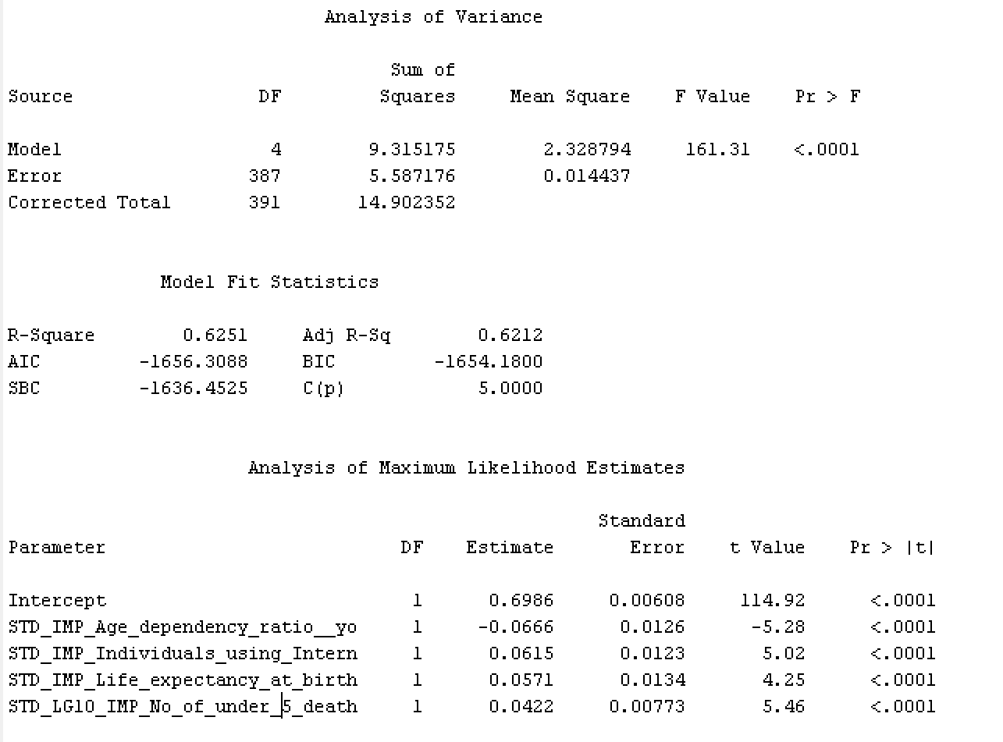

This model was run after rejecting the insignificant variable in Model 3. It is trained based on 391 observations and is significant because its Pr>F is smaller than 0.05 significance level. All four independent variables are significant in this model and they explain 62.15% (R square) of the variance because their Pr>F is smaller than 0.05 significance level. Significant variables are “Age dependency ratio, young (% of working-age population)”, “Life expectancy at birth, total (years)”, “Individuals using the Internet (% of population)”, and “Number of under-five deaths”.

**Linear Regression Equation:**

$$\hat{HDI}=0.6986-0.0666 Age dependency ratio, young (\% of working age population) +0.0615 Individuals using Internet+0.0571 Life expectancy at birth +0.0422 No of under 5 deaths$$

* **Model 4: Regression (4)**

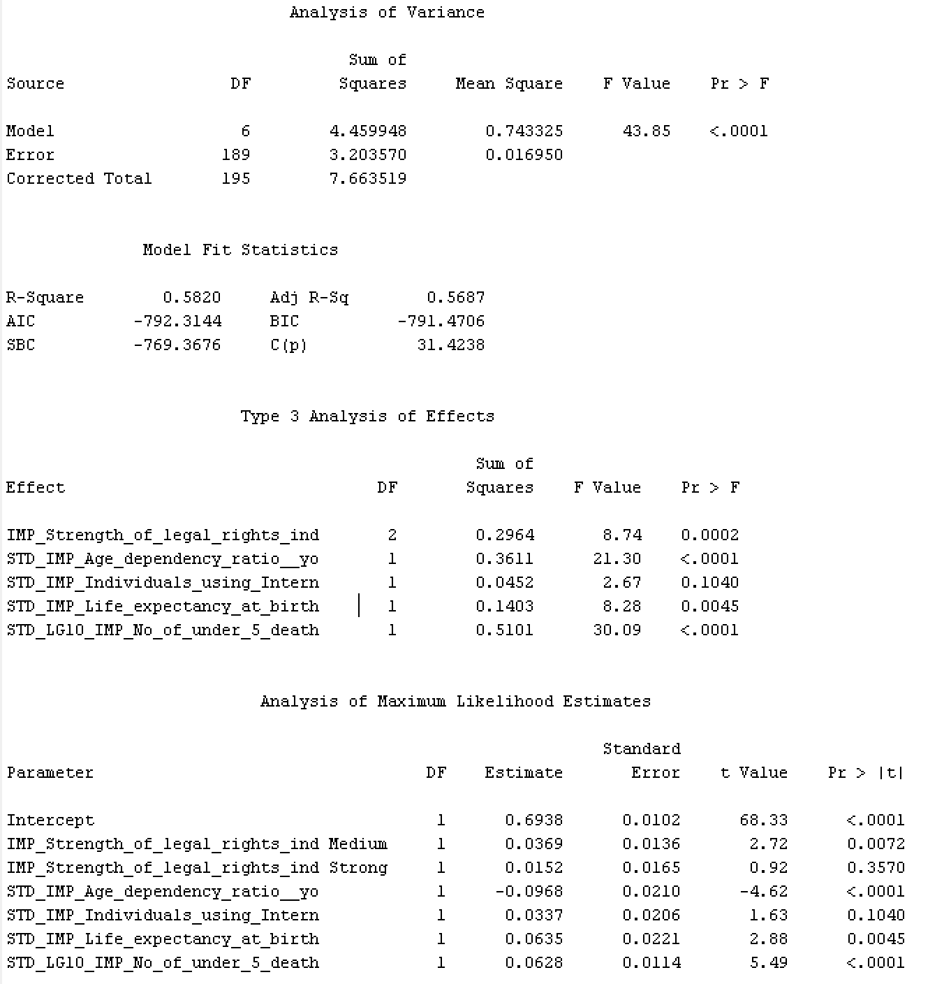

This model is trained based on 195 observations. The model is significant, but the individual variables “Strength of legal rights (Strong)” and “Individuals using Internet” are not significant according to the T-test, with p-values of 0.357 and 0.104 respectively. The model was run again rejecting the variable of “Strength of legal rights (strong)”, which is the most insignificant variable. Below are the results we obtained:

* **Model 4.2: Linear Regression 4.2**

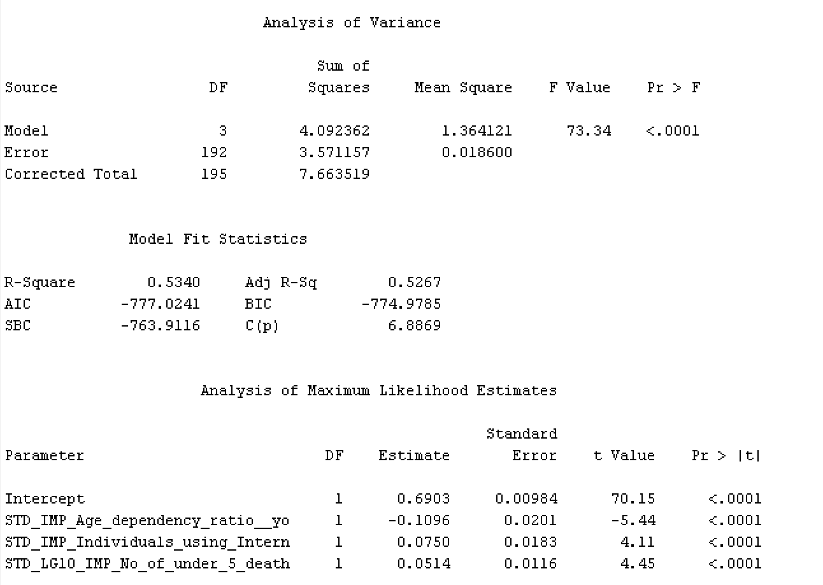

This model is run after rejecting insignificant variable in Model 4. The model is significant because its Pr>F is smaller than a significance level of 0.05. Three independent variables are significant in this model (Pr>F is smaller than 0.05) and they explain 53.40% (R square). The significant variables are “Age dependency ratio, young (% of working-age population)”, “Individuals using the Internet (% of population)”, ‘’No. of under 5 death”.

**Linear regression equation:**

$$\hat{HDI}=0.6903-0.1096 Age dependency ratio, young (\% of working age population)$$

$$+0.0750 Individuals using Internet -0.0514 Number of under five deaths$$

## **6.2 Regression Tree Models**

Four different regression tree models were run with a significance level of 0.2 but with a variation in data partition and data preprocessing (impute, transform, and variables selection).

Before impute, transform variables, and variable selection nodes:

1. **Regression Tree 1:** Data Partition 60/20/20
2. **Regression Tree 2:** Data Partition 30/40/30

After impute, transform variables, and variable selection nodes:

1. **Regression Tree 3**: Data Partition 60/20/20
2. **Regression Tree 4**: Data Partition 30/40/30

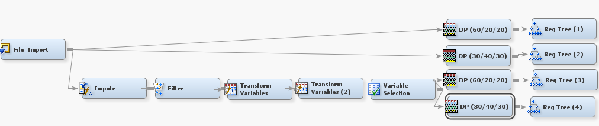

* **Model: Regression Tree 1**

The results of the regression tree 1 subtree assessment plot below shows that the training data and the validation data do not produce exactly the same results; however, they perform in a similar pattern until about leaf 31 after which they start going in different directions i.e. the error for the validation data increases whereas the error for the training data decreases.

The optimal tree has 29 leaves using GNI per capita PPP as the first split and the majority of the branches falling towards GNI per capita higher than or equal to $7,425. The two competing splits after that used GNI per capita PPP and No. of infant deaths. Based on the tree and the variable importance statistics below, 16 variables were important for the model. The five most important variables were ‘’GNI per capita PPP’’, ‘’Life expectancy at birth (total years)’’, ‘’Population growth (annual percentage)’’, ‘’Access to electricity percentage’’, and ‘’GDP per capita’’, with each of their variable importance being 1.0, 0.494, 0.3315, 0.1771, and 0.1099 respectively.

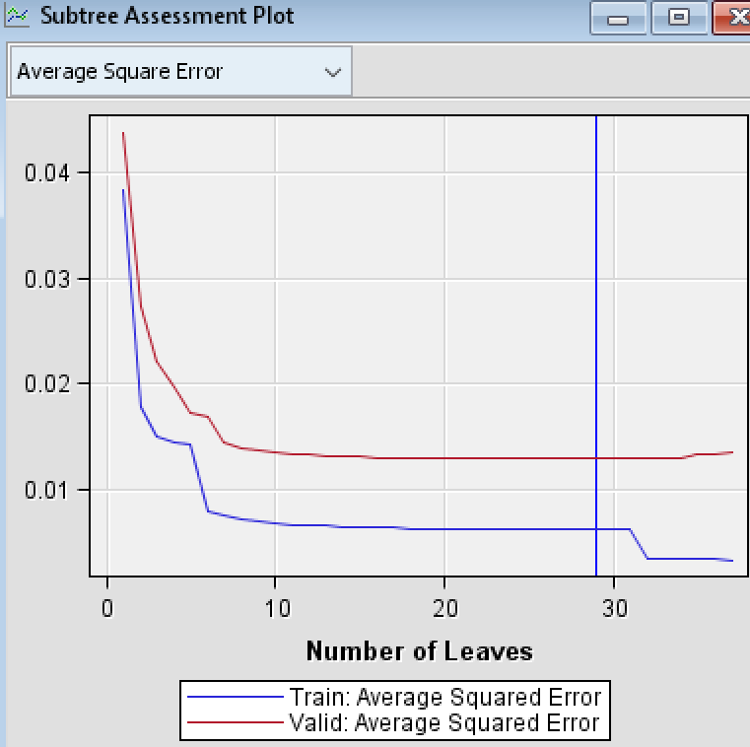

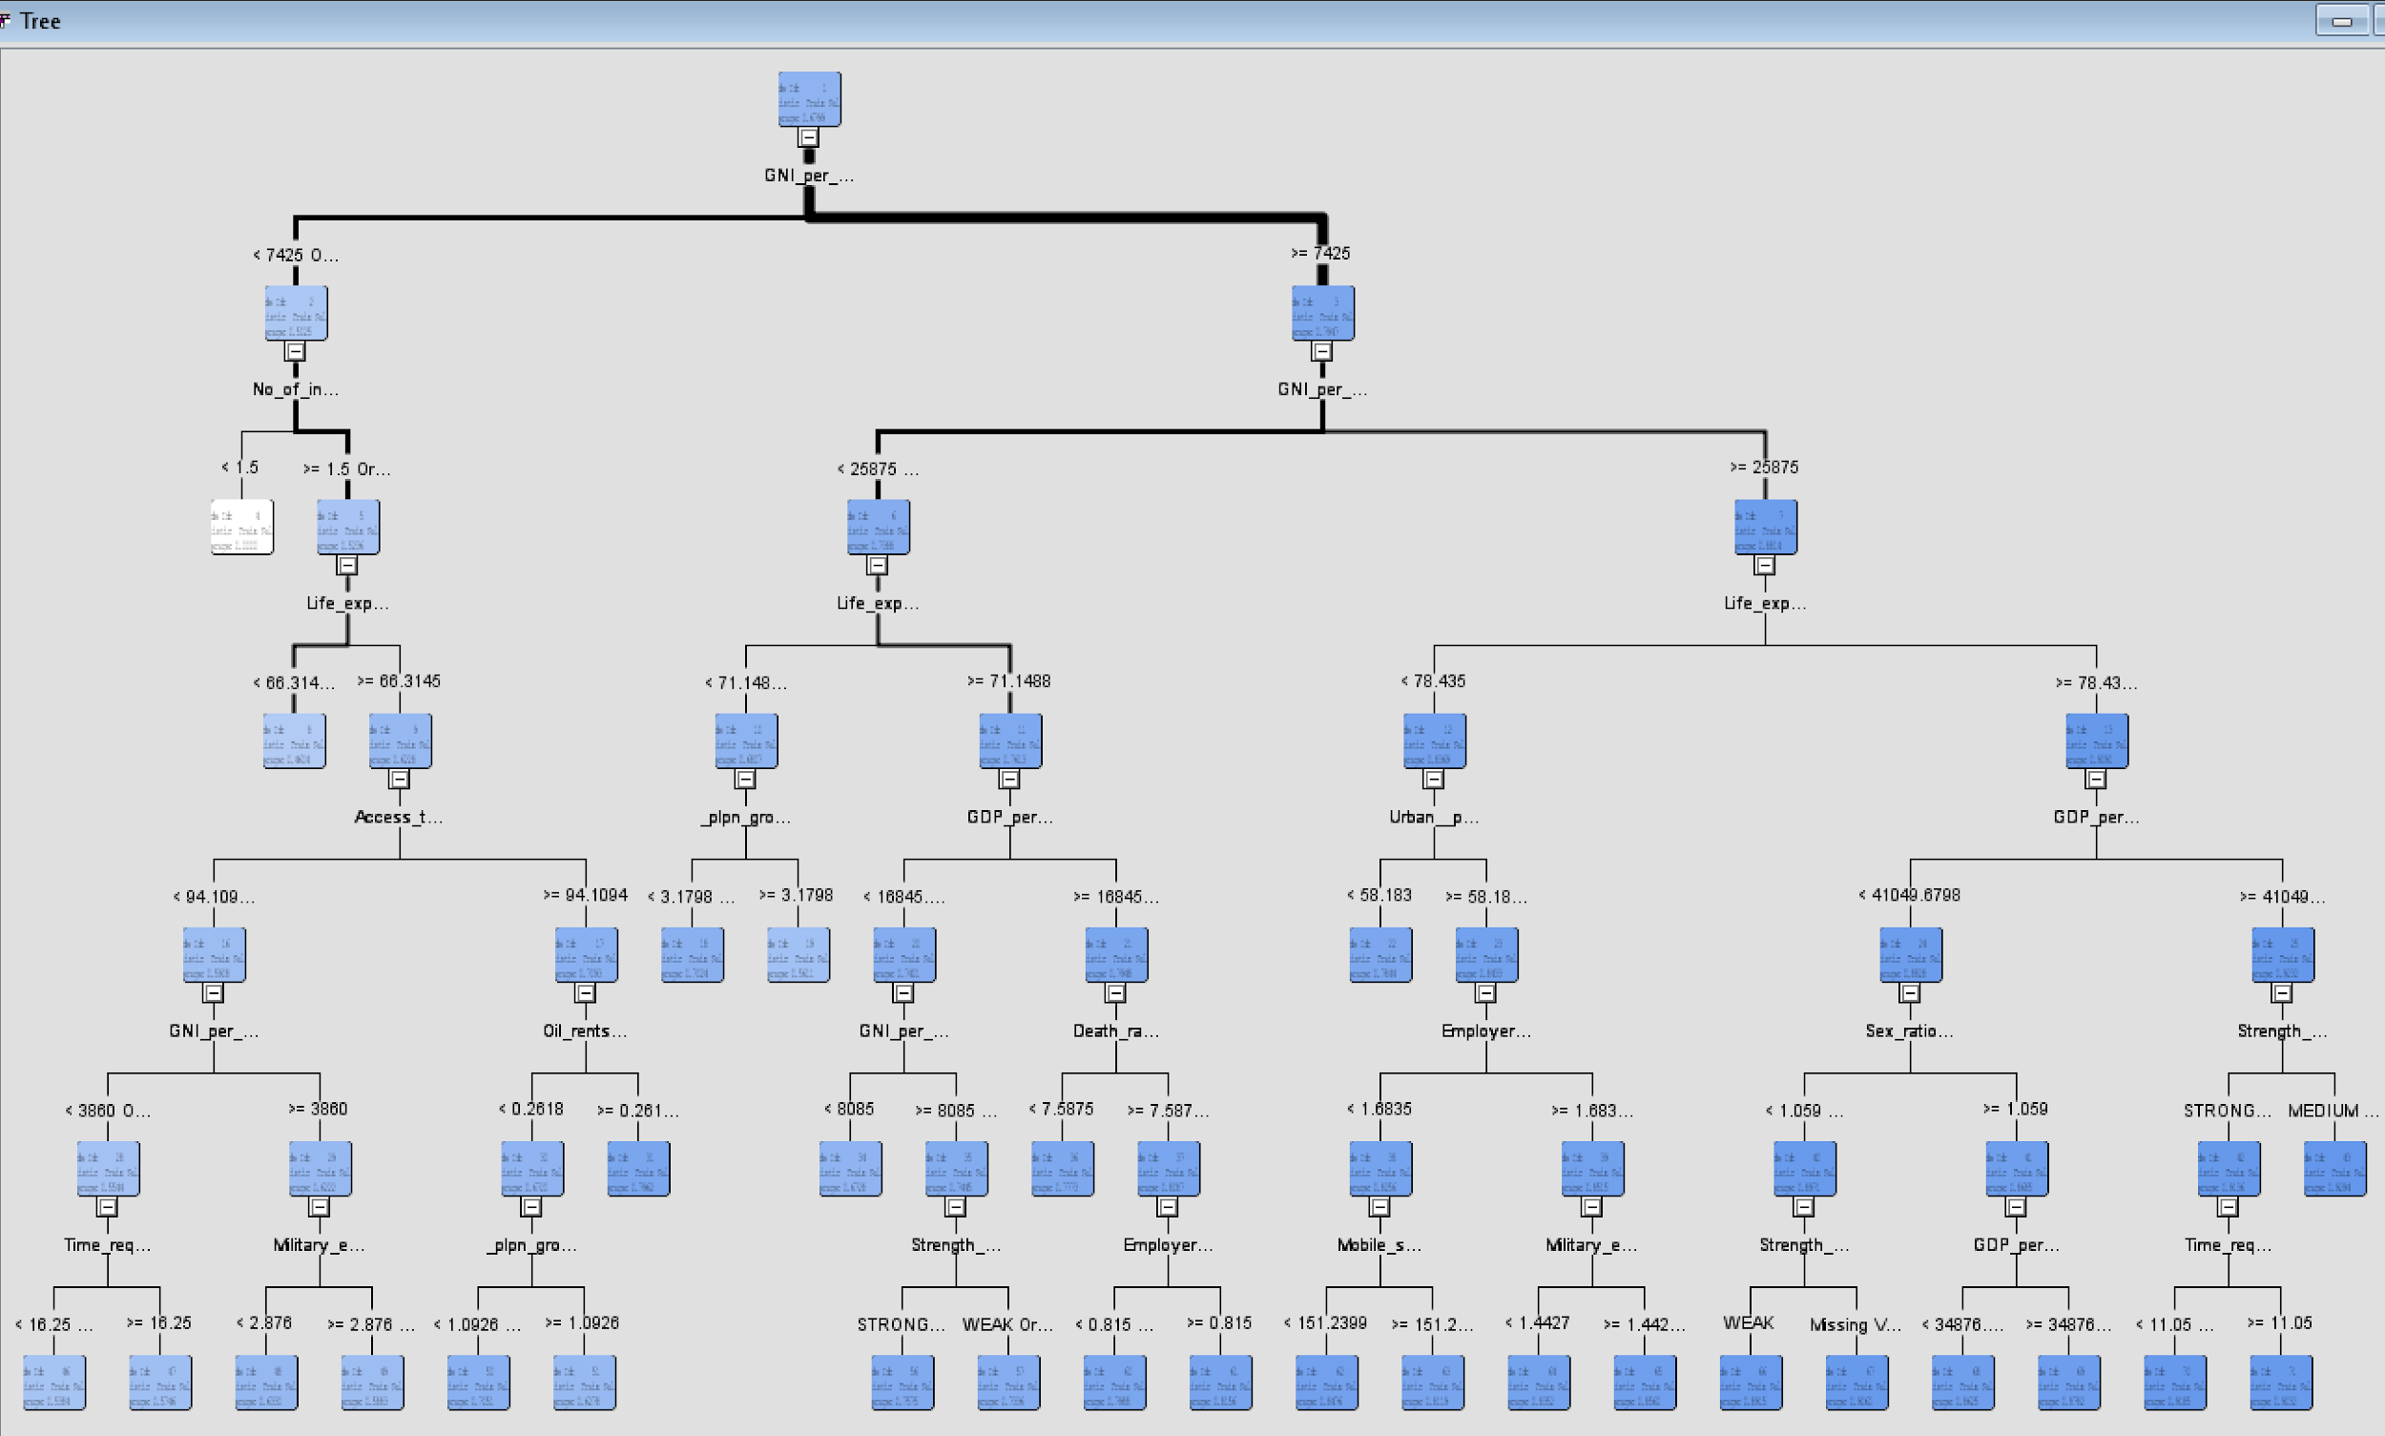

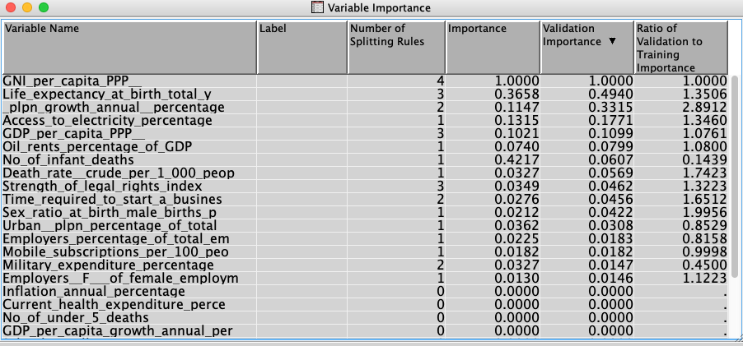

* **Model: Regression Tree 2**

The results of the regression tree 2 subtree assessment plot below show that the training data and the validation data perform in a very similar way from leaf 7 to leaf 13 and after that they start performing differently, in which their error rate substantially increases. The results suggest the optimal cutoff to be 10 leaves.

This tree uses GNI per capita PPP as the first split and the majority of the branches fall towards the node GNI per capita higher than or equal to $7,530. The second split is by GNI per capita again, but this time the dollar amount differed in which the criteria was higher than or equal to $23,030, and lower than $23,030 or missing. Based on the tree and the variable importance statistics below, 5 variables were important. Those variables were ‘’GNI per capita PPP’’, ‘’Life expectancy at birth (total years)’’, ‘’Mobile subscription per 100 people’’, ‘’GDP per capita PPP,’’ and ‘’Strength of legal rights index’’ with each of their variable importance being 1.0, 0.17, 0.07, 0.06, and 0.015 respectively.

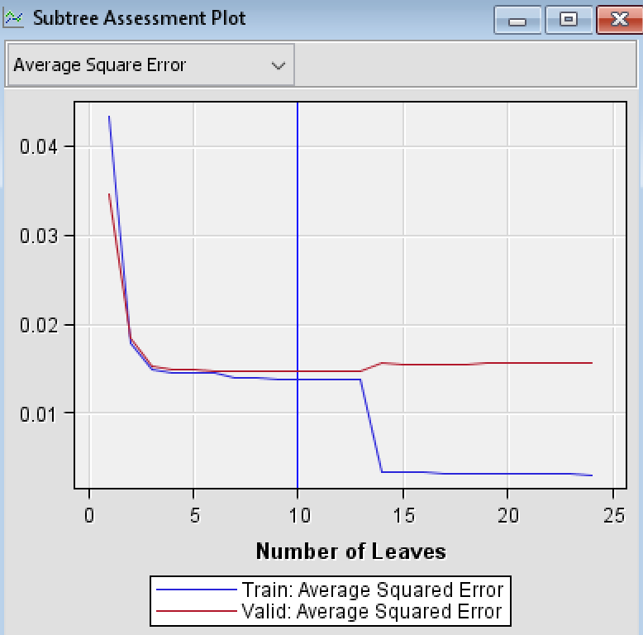

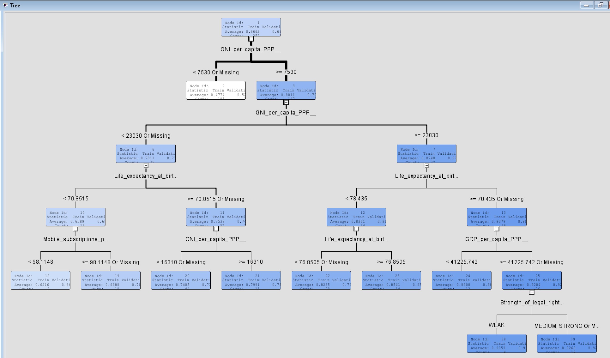

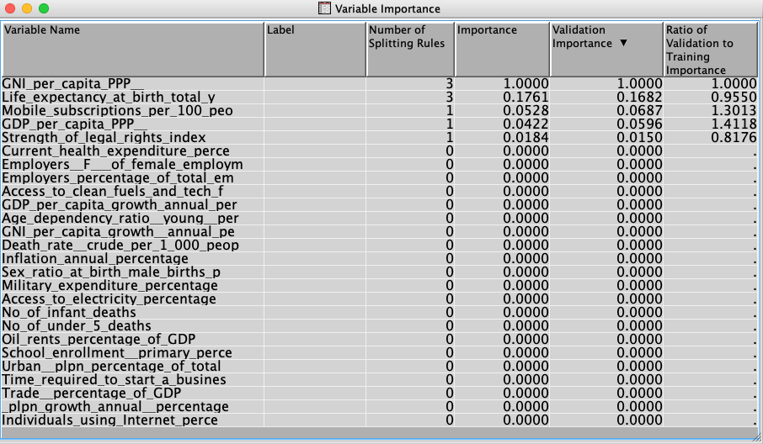

* **Model: Regression Tree 3**

The results of the regression tree 3 show that the optimal tree has 20 leaves using Access to clean fuels and tech for cooking (% of population) as the first split and the majority of the observations falling towards the branch that specifies the Access to clean fuels and tech for cooking (% of population) higher than or equal to -0.5175. Based on the tree and the variable importance statistics below, 7 variables are important. The five most important variables were: ‘’Access to clean fuels and tech for cooking (% of population)’’, ‘’Age dependency ratio (young percentage of working-age population)’’, ‘’Life expectancy at birth (total years)’’, ‘’Urban population (% of total population)’’, and ‘’Individuals using Internet (% of population)’’, with each of their variable importance being 1.0, 0.49, 0.44, 0.31, and 0.23 respectively.

The subtree assessment plot below shows that the training data and the validation data perform in a similar trend, the error decreases as the number of leaves increases and it stays very minimal after leaf 20.

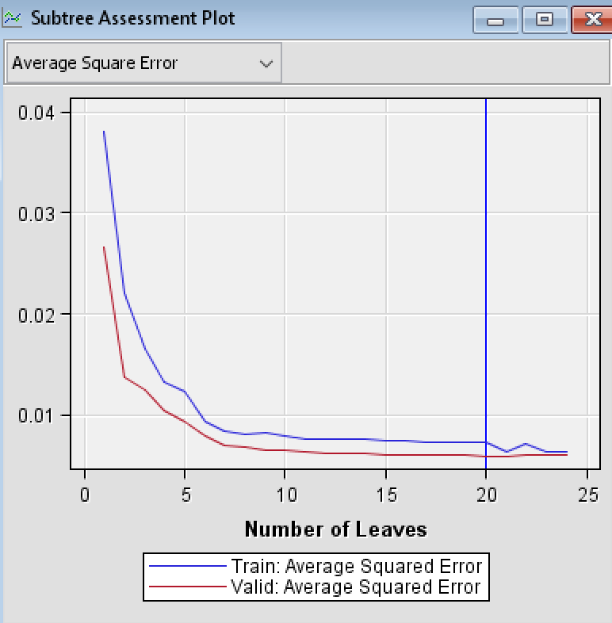

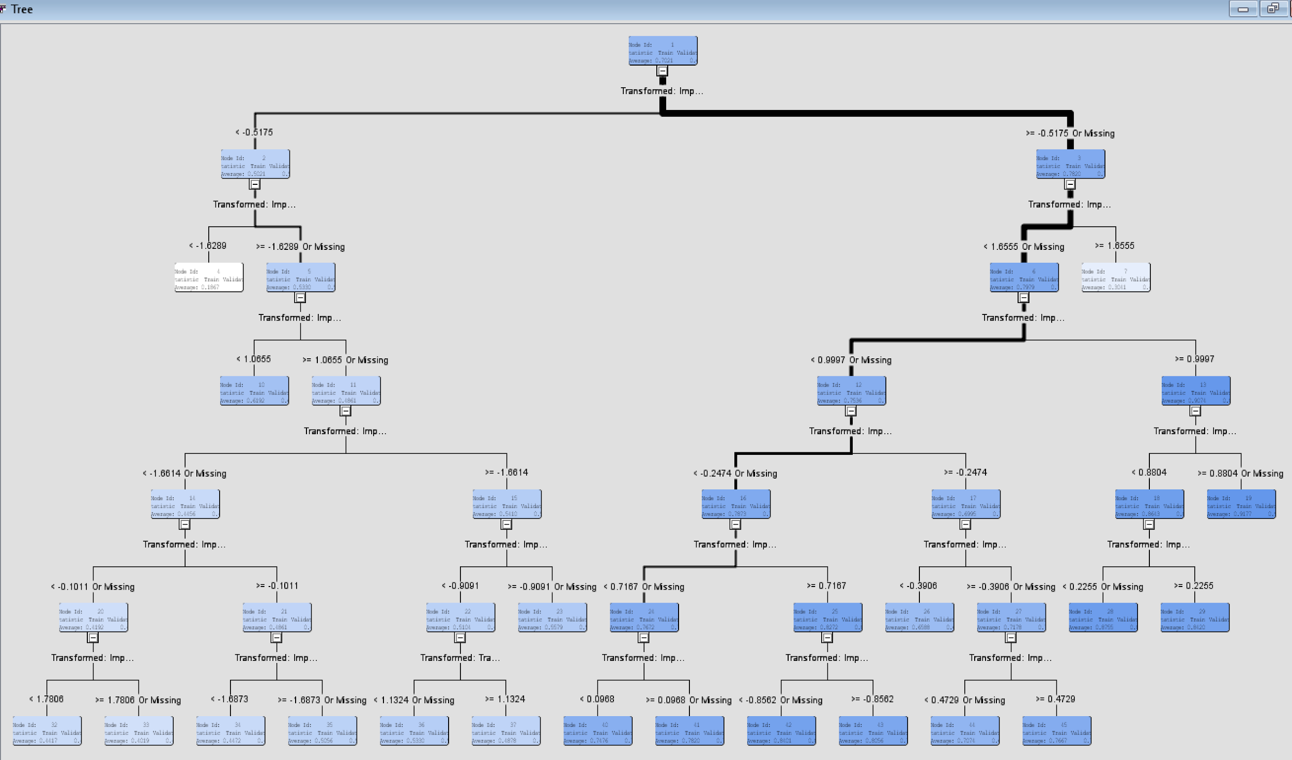

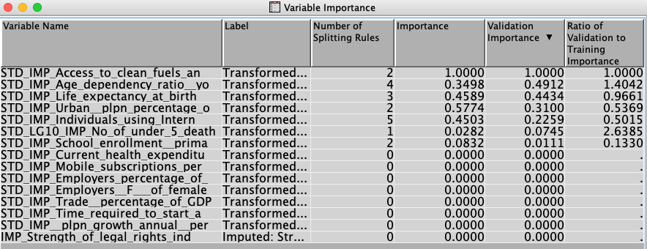

* **Model: Regression Tree 4**

The results of the regression tree 4 shows that the optimal tree has 16 leaves using Access to clean fuels and tech for cooking (% of population) as the first split and the majority of the observations falling towards the branch that specifies the “Access to clean fuels and tech for cooking (% of population)” higher than or equal to -0.5241. Based on the tree and the variable importance statistics below, 8 variables are important. The five most important variables were ‘’Access to clean fuels and tech for cooking (% of population)’’, ‘’Urban population (% of total population)’’, ‘’Individuals using internet (% of population)’’, ‘’Trade percentage of GDP’’, and ‘’Age dependency ratio (young percentage of working-age population)’’ with each of their variable importance being 1.0, 0.444, 0.442, 0.35, and 0.30 respectively.

The subtree assessment plot below shows that the training data and the validation data perform in a similar trend, but the error increases after leaf 16. So, the ideal cutoff seems to be leaf 16.

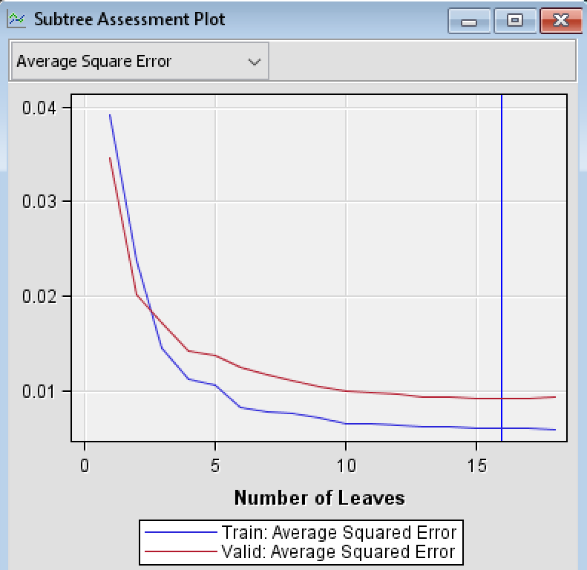

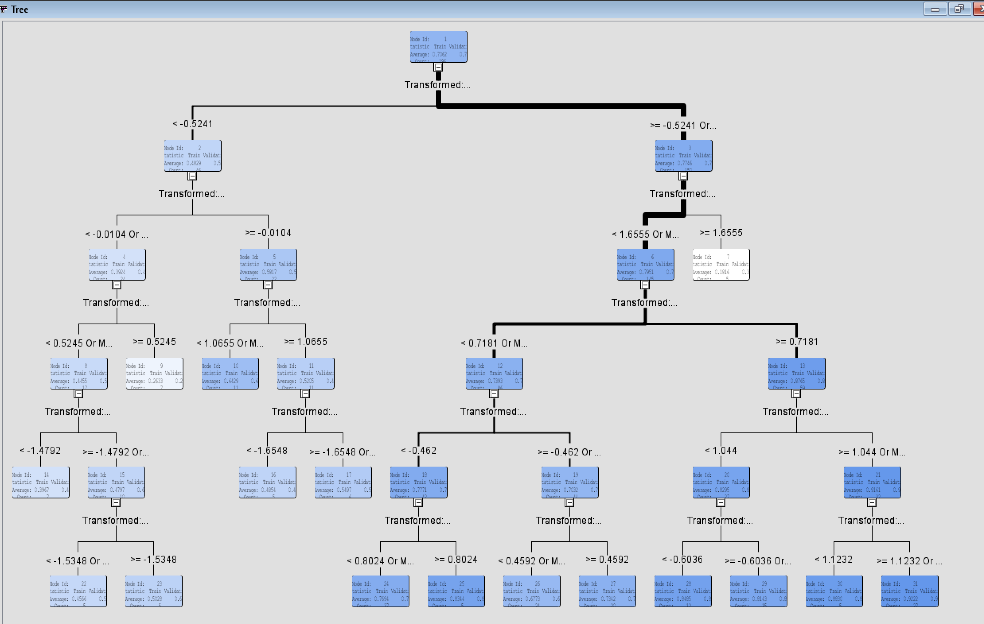

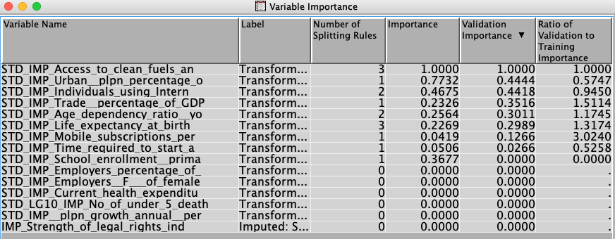

# **Model Comparison and Conclusions**

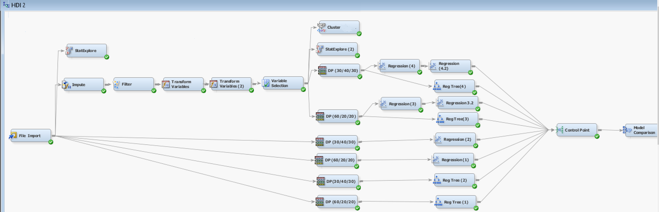

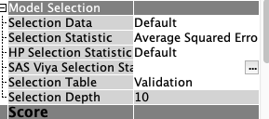

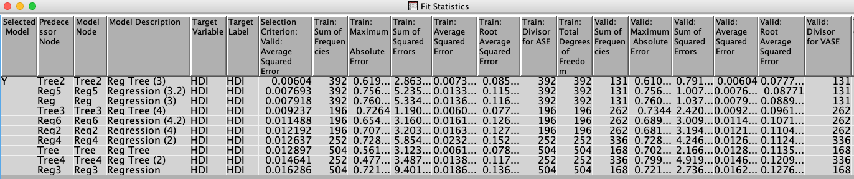

A control point was added to simplify the connection of all the models to a model comparison node. The selection criteria for the model comparison node was set to “Average Squared Error” and selection table set to “Validation”. The results show that Regression Tree 3 is the best model with the least average square error of 0.00604. Maximum absolute error, sum of squared errors, and root average squared error are also lower in Regression tree 3 in comparison to the other models. This was the model run with the data partition of 60% training, 20% validation, and 20% testing after imputing values, transforming the variables, and removing redundant variables. The results indicate that assigning more data to training increased the performance of Regression tree 3 because this was the only difference between Regression tree 3 and Regression tree 4. Similarly, data preprocessing methods such as imputing values, transforming variables, standardizing them, and rejecting the variable/s with overlapping information seems to have contributed to a better model performance in Regression tree 3 as well.

Selecting Regression Tree 3 as the most meaningful model, we can conclude that the variables: ‘’Access to clean fuels and tech for cooking (% of population)’’, ‘’Urban population (% of total population)’’, ‘’Life expectancy at birth (total years)’’, ‘’Individuals using Internet (% of population)’’, ‘’Age dependency ratio (young percentage of working-age population)’’, ‘’Number of under 5 deaths’’ and ‘’School enrollment (primary)’’ are the most important variables that explain the Human Development Index better. The results of the cluster analysis also show that most of these variables were important in grouping the countries into different clusters and that there were visible patterns represented by these variables in the clusters formed.

Other experimentation we did throughout this project also confirm that most of those seven variables have the highest importance compared to the other ones present in the dataset. Below is a matrix that shows the top 5 variables (highlighted red). These were selected after data exploration before preprocessing, data exploration after preprocessing, variable importance after cluster analysis, and variables importance after running each linear regression models and regression tree models. The total weight column is the sum of the recurrence of each variable in each data exploration and modeling process.

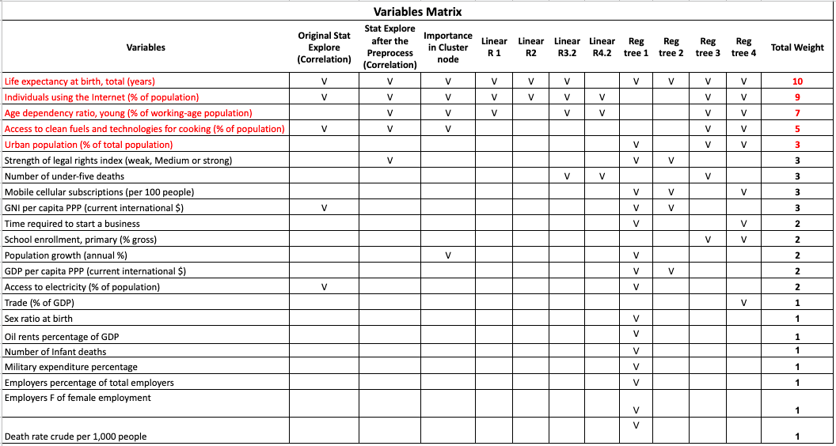

# **Managerial Implications**

The variables that resulted to be significant from our results can be taken into account by non-profit organizations, such as the United Nations, while allocating funding to important human development causes and also by a country in accessing its growth needs. Below are some of the areas that our data mining results can facilitate:

1. **Helping non-profit organizations in finding the most important causes:** There are many indicators of development and choosing one cause over the other can be a difficult task when there is limited funding. For instance, among ‘’Access to fuels and technology’’, ‘’Population using the internet’’, and ‘’School enrollment’’, it looks difficult to choose one because all of them look important. In this case, how can a non-profit organization identify which one they should focus on for development efforts? The results of this project can be useful during such dilemmas. By ranking different variables in order of importance based on correlations, this project can be used by nonprofits to find the causes that are most closely related to the problems they are trying to solve. This can help them save a lot of time and effort during fund raising or for allocating existing funds.
2. **Reducing risk:** Because this project can help nonprofits find the most important causes, it can help invest the donor’s money where it can make the most out of the investment, thus reducing risk of low returns on investment towards developmental efforts.
3. **Assisting awareness programs**: Once nonprofits know which causes are more important, they can tailor their awareness programs towards those causes. This can help create more meaningful awareness campaigns. This can also encourage governments to focus on those areas.
4. **Comparison of countries:** Cluster analysis categorized the countries into different groups giving us an idea of which countries were more similar to each other and which were dissimilar in terms of human development based on the indicators that we chose. This tells us which category of countries needs more aid to develop human conditions, so nonprofits can focus their efforts towards important causes in less developed countries to improve their life conditions.
5. **Attract donors with real data and insights visualization:** Data visualization can be of significant use when you are trying to convince donors towards specific causes. For a donor to donate money to a cause, they need to have an understanding of what they are contributing to and if they can improve human conditions. As a non-profit organization, by showing them the importance of different variables through insightful visualization, such as a cluster pie chart, where it separates countries into groups based on variable importance or a regression tree, where it splits the tree into multiple branches and shows which indicators have more importance than the others, you can deliver a more effective presentation towards donors and likely convince them to support important causes.
6. **Other variables importance:** The analysis identifies some other important variables, other than the top 5 we suggested, from our data that influence the HDI. When non-profit organization donates money to improve human development, they can have more options, rather than limiting themselves to the variables recommended by Ayesha (n. d.).

We initially thought that the variables that we chose for the dataset were closely related to the HDI; however, only a few of them turned out to be significant in explaining the human development index. This shows how subjective a human brain is to errors and how utilizing methods such as data mining and modeling with newer technological tools can be of significant importance in making better judgements. If we were to perform the evaluation by other methods such as MS Excel or manual mathematics, it would have likely taken a very long time to even get to the preliminary results. Thus, this project serves as an example of how important data mining techniques and tools can be in generating new insights from data.

# **Limitations**

* **Time:** Due to time limitation, we could not experiment with many mathematical techniques and compare the differences. Hence, there is a possibility to create a better model than the one we have, so data miners and modelers can experiment with mathematical techniques other than what we have used.
* **Data Availability and Inclusion:** Data availability is an issue, since not all the countries have information for many of the variables that were included in this analysis. Also, it is expected that more data will become available over time and this can improve the results of the model. Many variables that were available in the World database were not included in this project for simplicity i.e. so that the database does not become too big.

**Appendix 1: Variables**

|  |  |  |
| --- | --- | --- |
| **Variable** | **Type** | **Description** |
| Year | Date | Year the data was recorded |
| Country | Identifier | List of countries for which the data was recorded plus the year when data was recorded |
| Access to electricity  (% of population) | Numeric | Percentage of population with access to electricity. Weighted average value.Annual. |
| Access to clean fuels and technologies for cooking  (% of population) | Numeric | Is the proportion of total population primarily using clean cooking fuels and technologies for cooking. Under WHO guidelines, kerosene is excluded from clean cooking fuels. |
| Age dependency ratio, young (% of working-age population) | Numeric | Is the ratio of younger dependents (people younger than 15) to the working-age population (ages 15-64). The proportion of dependents per 100 working-age population. |
| Population growth (annual %) | Numeric | Annual population growth rate. Weighted average. |
| Current health expenditure  (% of GDP) | Numeric | Level of current health expenditure expressed as a percentage of GDP. Estimates of current health expenditures include healthcare goods and services consumed during each year. This indicator does not include capital health expenditures such as buildings, machinery, IT and stocks of vaccines for emergency or outbreaks. |
| Death rate, crude  (per 1,000 people) | Numeric | Indicates the number of deaths per 1,000 midyear population. |
| Employers, total (% of total employment)  (modeled ILO estimate) | Numeric | Employers are those workers who, working on their own account or with one or a few partners, hold the type of jobs defined as a self-employment jobs" i.e. jobs where the remuneration is directly dependent upon the profits derived from the goods and services produced) |
| Employers, female (% of female employment)  (modeled ILO estimate) | Numeric | Employers are those workers who, working on their own account or with one or a few partners, hold the type of jobs defined as a self-employment jobs" i.e. jobs where the remuneration is directly dependent upon the profits derived from the goods and services produced) |
| Urban population  (% of total population) | Numeric | Urban population refers to people living in urban areas as defined by national statistical offices. The data are collected and smoothed by United Nations Population Division. |
| Trade (% of GDP) | Numeric | Is the sum of exports and imports of goods and services measured as a share of gross domestic product. |
| Time required to start a business (days) | Numeric | The number of calendar days needed to complete the procedures to legally operate a business. If a procedure can be speeded up at additional cost, the fastest procedure, independent of cost, is chosen. |
| Sex ratio at birth  (male births per female births) | Numeric | Refers to the amount of male births per female births. |
| Individuals using the Internet (% of population) | Numeric | Internet users are individuals who have used the Internet (from any location) in the last 3 months. Weighted average. Annual. |
| Inflation, consumer prices (annual %) | Numeric | Reflects the annual percentage change in the cost to the average consumer of acquiring a basket of goods and services that may be fixed or changed at specified intervals, such as yearly. Median. Annual. |
| School enrollment, primary  (% gross) | Numeric | Gross enrollment ratio is the ratio of total enrollment, regardless of age, to the population of the age group that officially corresponds to the level of education shown. Primary education provides children with basic reading, writing, and mathematics skills along with an elementary understanding of such subjects as history, geography, natural science, social science, art, and music. |
| Oil rents (% of GDP) | Numeric | Is the difference between the value of crude oil production at world prices and total costs of production. |
| Number of under-five deaths | Numeric | Number of children dying before reaching age five. |
| Number of infant deaths | Numeric | Number of infants dying before reaching one year of age. |
| GNI per capita growth  (annual %) | Numeric | Weighted average annual percentage growth rate of GNI per capita based on constant local currency. Aggregates are based on constant 2010 U.S. dollars. GNI per capita is gross national income divided by midyear population. GNI (formerly GNP) is the sum of value added by all resident producers plus any product taxes (less subsidies) not included in the valuation of output plus net receipts of primary income (compensation of employees and property income) from abroad. |
| GNI per capita PPP  (current international $) | Numeric | Weighted average of annual Gross National Income per capita based on purchasing power parity (PPP means converted to international dollars using purchasing power parity rates). An international dollar has the same purchasing power over GNI as a U.S. dollar has in the United States. GNI is the sum of value added by all resident producers plus any product taxes (less subsidies) not included in the valuation of output plus net receipts of primary income from abroad. Data are in current international dollars based on the 2011 ICP round. |
| GDP per capita growth  (Annual %) | Numeric | Weighted average annual percentage growth rate of GDP per capita based on constant local currency. GDP per capita is gross domestic product divided by midyear population. GDP at purchaser's prices is the sum of gross value added by all resident producers in the economy plus any product taxes and minus any subsidies not included in the value of the products. |
| GDP per capita PPP  (current international $) | Numeric | GDP per capita based on purchasing power parity (PPP). PPP GDP is gross domestic product converted to international dollars using purchasing power parity rates. An international dollar has the same purchasing power over GDP as the U.S. dollar has in the United States. GDP at purchaser's prices is the sum of gross value added by all resident producers in the economy plus any product taxes and minus any subsidies not included in the value of the products. It is calculated without making deductions for depreciation of fabricated assets or for depletion and degradation of natural resources. |
| Strength of legal rights index (weak, Medium or strong) | Nominal | Measures the degree to which collateral and bankruptcy laws protect the rights of borrowers and lenders and thus facilitate lending. The index ranges from 0 to 12, with higher scores indicating that these laws are better designed to expand access to credit. |
| Life expectancy at birth, total (years) | Numeric | Weighted average of annual life expectancy at birth indicates the number of years a newborn infant would live if prevailing patterns of mortality at the time of its birth were to stay the same throughout its life. |
| Military expenditure  (% GDP) | Numeric | Weighted average of annual military expenditures, which includes all current and capital expenditures on the armed forces, paramilitary forces, and military space activities. Such expenditures include military and civil personnel, operation and maintenance, procurement, military research and development, and military aid. Excluded are civil defense and current expenditures for previous military activities. |
| Mobile cellular subscriptions (per 100 people) | Numeric | Weighted average of annual subscriptions to a public mobile telephone service that provides access to the PSTN using cellular technology. The indicator includes (and is split into) the number of postpaid subscriptions, and the number of active prepaid accounts. The indicator applies to all mobile cellular subscriptions that offer voice communications. It excludes subscriptions via data cards or USB modems, to public mobile data services and similar.. |
| Human Development Index (HDI) | Numeric | Measures the average achievements in a country in three basic dimensions of human development: a long and healthy life, access to knowledge and a decent standard of living. It is a geometric mean of normalized indices measuring achievements in each dimension. |

# **References and Links:**

* **References:**

Ayesha (n.d). Human Development Index (HDI): Indicators & Shortcomings | Economics. Retrieved from: <http://www.economicsdiscussion.net/economic-development/hdi/human-development-index-hdi-indicators-shortcomings-economics/29945>

Jahan S. (n. d.) The Human Development Index – what it is and what it is not

Retrieved from The United Nations Development Programme: <http://hdr.undp.org/en/hdi-what-it-is>

* **Link to the database:**

<https://docs.google.com/spreadsheets/d/1Q-8-uCacbW4DBhipwue8uR-qJKwCYQnior8xpy6oJRI/edit?usp=sharing>